Document of the Inter-American Development Bank

Guyana

Sustainable Agricultural Development Program
(GY-L1060)

Report of the Consultant for Component 2:
Strengthening of the agricultural innovation and extension system

By

Dr. Leslie A. Simpson
IDB Consultant

25 August 2016
Table of Contents
Programme Description - Component 2 6
A summation of the activities of the Consultancy and scope of this report 7
Activities of the consultancy 8
Initial meeting with personnel from the Ministry of Agriculture – 23 June 2016 8
Meetings with other key stakeholders in Guyana 9
Visit to Ebini Station 12
Visit to the Rupununi Savannah 15
Visit to Brazil 20
Literature and documents review 21
Review of strategic plans drafted by NAREI and GLDA 21
- Strategic plan of NAREI 21
- Strategic plan of GLDA 26
Feasibility of long term plan and identification of potential beneficiaries 29
Analysis of gaps and requirements based on long term vision developed by NAREI and GLDA. 30
Proposed Research and Extension Programme for the IS and RS 31
Intermediate Savannahs 32
Rupununi Savannahs 45
Details of the Extension Proposal 62
Recommendations and Conclusion 66
Documents Consulted 67
Personnel Consulted 69
ANNEXES 72
ANNEX 1. Agenda Leslie Simpson – First Mission 72
ANNEX 2. Inventory of the Ebini Agricultural Station 73
ANNEX 3. Soil Mapping Units for Region 9 Rupununi 74
ANNEX 4. Requirements of the Ebini station 75
ANNEX 5. List of Chemicals and Equipment needed for the re-activation of the NAREI Laboratory at Mon Repos 77
ANNEX 6 Crop production packages in the Intermediate Savannahs for selected commodities 84

Acronyms and Abbreviations
AC - Agricultural Centre
ADG - Average Daily Gain
ADP - Agricultural Diversification Programme
ADP - Amerindian Development Programme
AI - Artificial Insemination
CARICOM - Caribbean Community
CEA - Crop Extension Officer
CEO - Chief Executive Officer
CI - Conservancy International
CIAT - International Center for Tropical Agriculture
CIMH - Caribbean Institute for Meteorology and Hydrology
DAP - Days after planting
EMBRAPA - Brazilian Agricultural Research Corporation
ETC - Extension Training Centre
EU - European Union
FAO - Food and Agricultural Organisation
FFS - Farmer Field School
GLDA - Guyana Livestock Development Authority
GRDB - Guyana Rice Development Board
GRIF - Guyana REDD+ Investment Fund
GSRJ - Global Scholastic Research Journal
GUYSUCO - Guyana Sugar Corporation
GY - Guyana
IAST - Institute of Applied Science and Technology
ICT - information and communications technology
IDB - Inter-American Development Bank
IICA - Inter-American Institute for Cooperation on Agriculture
IITA - International Institute for Tropical Agriculture
IR - Intermediate Savannahs
ISNAR - International Service for National Agricultural Research
LBI - La Bonne Intention
LCDS - Low Carbon Development Strategy
LEA - Livestock Extension Assistant
LEO - Livestock Extension Officer
MAP - Months after planting
MoA - Ministry of Agriculture
NAREI - National Agricultural Research and Extension Institute
NDIA - National Drainage and Irrigation Authority
OPAS - Organizational Performance Assessment System
PBM - Potential Bull Mothers
RCB - Randomized Complete Block
REDD - Reducing emissions from deforestation and forest degradation
RLPA - Rupununi Livestock Producers Association
RS - Rupununi Savannahs
SCEO - Senior Crop Extension Officer
SLEO - Senior Livestock Extension Officer
SPS - Sanitary and Phytosanitary
SWOT - Strengths Weakness Opportunities Threats
UG - University of Guyana
UNDP - United Nations Development Programme
USA - United States of America
Executive Summary
The Inter-American Development Bank is preparing a project for a new loan for the agricultural sector in Guyana. This loan programme is entitled the “Sustainable Agriculture Development Program” (GY-L1060) and will focus its activities in Region 9 and Region 10. Its objective is to increase the productivity of the agricultural sector while maintaining a sustainable and climate resilient use of natural resources in Guyana.

This loan will be implemented by the Ministry of Agriculture (MoA) and has three main components.
Component 1: Generating information for evidence – based policy making and natural resource management
Component 2: Strengthening of the agricultural innovation and extension system.
Component 3: Support for compliance with sanitary and phytosanitary standard

This document is the report of the consultant contracted by the IDB to assist the Ministry of Agriculture in Guyana in the design of component 2

The consultant made two missions to Guyana to facilitate the execution of this consultancy. In the first mission meetings were held with as many stakeholders as possible including the MoA, NAREI, GLDA. Visits were also made to Ebini in the Berbice River which is part of the Intermediate Savannahs in Region 10 of Guyana and to the South Rupununi area which is a part of the Rupununi Savannahs of Region 9. During these meetings and visits the consultant collected relevant data on the two focus areas and was also able to analyze crop and livestock production systems in Regions 9 and 10, including an assessment of current applied research and extension activities; and get reactions from persons in the two areas on the relevance of agriculture and the proposed development program.

From the first mission, reviews of the strategic plans of the national livestock agency, GLDA and the national crop research and extension agency, NAREI and perusal of the documentation received on the mission a preliminary report was developed and submitted to IDB. This report detailed the physical resources and ecological conditions of the two locations including their similarities and differences. It gave the constraints to agricultural production which were quite similar and related to soils and climate in the two locations. These constraints were used in some measure to design draft research proposals for the two areas. The extension proposal flowed from the research proposal and included the use of new participatory methods of agricultural technology transfer and the use of ICTs.
On the second mission, the consultant sought to have further discussions with the main national stakeholders NAREI and GLDA, particularly to get more precise details of the research and extension proposals. This also led to discussions with other agricultural agencies which are likely to be collaborators on the project such as GUYSUCO to form some options on their involvement. During the second Mission, the consultant was also able to interact with the other consultants on the programme and make a presentation on the research and extension proposals to them and the national stakeholders.
Feedback from the presentation and the consultations during the second mission were used to develop a more detailed research proposal in this report. The research proposal entails the carrying out some activities in five broad areas of research in the two locations. These five broad areas are as follows:
- Perennial crops (Orchard crops) Research
- Annual crops Research
- Livestock feeds and feeding systems Research
- Livestock Research – Breeds and breeding
- Soil management
From the details of the research studies to be conducted it was possible to work out the infrastructure, human resources equipment and material needs for the two proposed Agricultural Centres and these are detailed in the report.
The details of the technology transfer and farmer training proposal encompassed the transfer of developed technologies to the farming community by a variety of methods including the “Hub and Spoke” model, the use of Farmer Field Schools (FFS) and the use of more advanced ICTs. The details of the system also allowed for the working out of the human resources needs in this area. In addition, information was also sought and acquired for the cost of production of some of the commodities to be grown in the savannahs to facilitate the introduction and use of an incentive programme for the small producers in the two areas.

Introduction
The Inter-American Development Bank is preparing a project for a new loan for the agricultural sector in Guyana. This loan programme is entitled the “Sustainable Agriculture Development Program” (GY-L1060) and will focus its activities in Region 9 and Region 10. Its objective is to increase the productivity of the agricultural sector while maintaining a sustainable and climate resilient use of natural resources in Guyana.

This loan will be implemented by the Ministry of Agriculture (MoA) and has three main components.
Component 1: Generating information for evidence – based policy making and natural resource management
Component 2: Strengthening of the agricultural innovation and extension system.
Component 3: Support for compliance with sanitary and phytosanitary standard

Programme Description - Component 2
Component 2: Strengthening of the agricultural innovation and extension system.
The program will finance the establishment of agriculture centers, to contribute to local and regional development, including technology transfer, demonstration and training. Two centers have been identified by the MoA:
- Lethem / Manari (Region 9); and
- Ebini (Region 10).

In both sites, the program will finance infrastructure (new and upgrades to existing buildings), equipment and technical assistance. The infrastructure will be used for research, training and extension. Land is owned and will be provided by the MoA.

Research / demonstration programs, identified through a prioritization exercise, will be implemented in collaboration with national and international centers. These programs will identify specific beneficiary groups, technology packages and monitoring and evaluation mechanisms. Research activities will focus on reducing vulnerability to climate change through multiplication and conservation of genetic material, including drought resistant varieties and protection of traditional knowledge as local adaptation strategy.

This consultancy is part of the feasibility and technical studies needed for IDB Board approval.
The objective of the consultancy is two-fold:
- analyze agriculture/livestock production systems in Regions 9 and 10, including an assessment of current applied research and extension activities in the sector, and the biophysical and socioeconomic factors influencing productivity in the region; and
- based on the analysis, develop a research program to test, in cooperation with Guyana’s National Agricultural Research and Extension Institute (NAREI) and the Guyana Livestock Development Authority (GLDA), as well as local agricultural extension agencies, an innovative integrated land management approach for sustainable crop/livestock production in the study area, which can be scaled up to the wider region in the future.

The analysis report and research plan will inform the design of priority public investments to be presented as part of the Sustainable Agricultural Development Program (GY-L1060) to be proposed for IDB financing to the Government of Guyana.

Activities
The specific tasks required to accomplish the objective may be grouped into two task areas:
- analysis of existing applied research & extension capacity in the agricultural sector; and
- design of research programs to enhance crop and livestock productivity on small- and medium sized farms.

A summation of the activities of the Consultancy and scope of this report
In order to begin this analysis of existing Applied Research and Extension Capacity a scoping mission was made to Guyana over the period 22 June – 02 July 2016. The itinerary for this mission is given Annex 1.

During this mission the consultant held meetings with MoA, NAREI, GLDA, extension agents and other stakeholders such as the Guyana Offices of FAO, IICA and UNDP. These meetings facilitated the collection data and determine the present status of research and extension operations at Ebini and Rupununi. In the case of FAO and IICA it also allowed the introduction of the programme and the invitation for “buy-in” to the programme which accepted by both organisations.

At the end of this mission, the consultant also reviewed many relevant documents such as the strategic plans of both NAREI and GLDA, other technical reports and journal papers on the areas of interest and developing technologies. From all the various reviews and considerations a preliminary was prepared detailing the activities on the project and ending with a draft proposals of the research and extension activities needed for the two areas and the infrastructural support required to support these proposals.
I
n a second mission to Guyana undertaken over the period 08 – 25 August 2016, further discussions were conducted with persons of interest in the agricultural sector particularly personnel from NAREI, GLDA and GUYSUCO to get more detailed information on research needs and services available to the agricultural sector. A presentation was also made to personnel of the MoA, NAREI and GLDA highlighting updated proposals for the research and extension activities needed for the two areas. The presentation also gave more details on the human resources, infrastructural, material and equipment needs to support the programme.

This report therefore encompass all the activities of the consultancy and covers the tasks required i.e. an analysis of the existing applied research & extension capacity in the agricultural sector with specific reference to Regions 9 and 10 and the design of research programs to enhance crop and livestock productivity on small- and medium sized farms in the two locations.

Activities of the consultancy

Initial meeting with personnel from the Ministry of Agriculture – 23 June 2016
An initial meeting was held with representatives from the Ministry of Agriculture (MOA) Guyana Livestock Development Authority (GLDA) and National Agricultural Research and Extension Institute (NAREI) on 23 June 2016 at the MOA Board Room
Present were: Mr Bill Anderson – Consultant Component 3
Mr Kelvin Clarke – Consultant Component 2 – Infrastructural development
Mr Nigel Cumberbatch – CEO GLDA
Mr George Jervis – PS MOA
Mr Khemlall Alvin
Dr Mark Pierre
Dr Leslie Simpson – Consultant Component 2 – Research Proposal Development

Research Proposal Development
Discussions began around the first question asked about the vision the Ministry of Agriculture has for the agricultural development of the two savannah areas. It was stated that these two areas are considered to be the next frontiers for agricultural development in the country. But in order to take up that role certain infrastructure must be developed.

In the intermediate savannahs, the Ebini agricultural centre will service the surrounding savannah areas of Kimbia, Tacama, Ebeorabo etc. While the agricultural centre to be developed at Manari in the Rupununi savannahs will service the research and extension needs of the savannah areas in north and south Rupununi. It is also planned that the agricultural centre in the Rupununi would also house a campus of the Guyana School of Agriculture (GSA) so that extension officers can be trained from the immediate vicinity.

This vision is centered on the “Hub and spoke” farm model system. The “Hub & Spoke” farm model allows inclusion of commercial and smallholder farming in a symbiotic relationship leading to sustainable development of smallholder farmers. In the context of Guyana the development of large mechanized farms such as the Citrus Growers of Trinidad and Tobago Farm at Tacama, Berbice river and Santa Fe, in the Rupununi form the hub with the spokes being smaller enterprises (satellite farmers) which support the production of the Hubs. The Government agencies NAREI and GLDA would support the development of the “Hub and spoke” system in the savannahs through innovative research and extension of new technologies and the development of investment packages for medium and large scale enterprises which may be seeking to invest in the savannahs.

The discussion then centered on the priority enterprises for the two areas to realize the vision articulated:
The commodities of interest in the Intermediate Savannas (IS) were given as:
- Orchard Crops: Avocado, Citrus, Guava and Soursop
- Row cops: Cassava, Corn, Cowpeas and Soybeans
- Livestock: Cattle and small ruminants (Sheep)

While the commodities in the Rupununi Savannahs (RS) were:
- Orchard Crops: Citrus, Guava, Mango and Passion Fruit
- Row cops: Cassava, Corn, Rice and Soybeans
- Livestock: Beef Cattle and small ruminants (Sheep and goats)

The research needs to support the vision and the production of the commodities envisioned are related to the following challenges which are faced in the two ecosystems:

Intermediate Savannas (IS)
- Water management as a result of drought and the poor water holding capacity of the soils
- Low yielding varieties, acid, low fertility soils and poor crop nutrition
- Poor quality forages and low management of pastures, need for mineral supplements
- Need for improved breeds and enhancement of genetic stock

Rupununi Savannahs (RS)
- Water management as a result of drought followed by floods
- Low yielding varieties, acid, low fertility soils and poor crop nutrition
- Poor quality forages and low management of pastures, need for mineral supplements
- Need for improve breeds and enhancement of genetic stock

This meeting was very fruitful as it gave the consultant a solid base on which to assess the other activities on this first mission.

Meetings with other key stakeholders in Guyana

Meeting with the FAO Representative in Guyana – Mr Reuben Robertson

Mr Robertson was quite receptive to the proposed programme. He pledged the support of FAO in any way possible. He said FAO is strong partner in the development of agriculture in Guyana and would be willing to give support to the programme in its various areas of competence.

He was particularly interested in the development of the new abattoir in Region 5. He felt it should be modular to cater for further expansion and the use of new technologies. As a result of his interest in the abattoir, I shared his contact information with Mr Bill Anderson, Consultant, Component 3.

Mr Robertson was also interested in what he called the “capacity building of farmers.” He felt this could be best achieved through a market approach where extension was demand driven. In this approach capacity building is achieved through the strengthening of Farm organisations and producer Groups and the development of value chains for the commodities of interest. He also mentioned the strengthening of the Extension system through the use of Farmer Field Schools (FFS) a methodology that FAO has pioneered in the Caribbean.

In the present programme he felt that farmers could be further advanced by having secondments to the proposed agricultural centres and even for best practices demonstration farmers could also be sent to place like Brazil and other countries with similar agricultural challenges. The centres can also provide certification through structured training to suitable persons in the areas to replenish the Extension services.

Meeting with the IICA Representative in Guyana – Mr Wilmot Garnett
The IICA representative was similarly quite receptive to the programme. He indicated that IICA is interested in an integrated approach to agricultural development utilizing private/public partnerships. He mentioned the IICA agro-tourism programme in the Caribbean as a good example of a working private/public partnership. He also mentioned that IICA is working with Conservation International (CI) in Guyana which had the same approach.

Mr Garnett also mentioned the present SPSS programme which IICA is spearheading in the Caribbean with support from the European Union (EU). This programme he pointed out is in the process of developing model Bills for the Caribbean in:
- Food safety
- Plant and Animal Health
- Wildlife
As well as the harmonization of the national legislations of the countries of the Caribbean in these important areas.

Mr Garnett also indicated that IICA is very interested in the Rupununi area and has been part of some of the initiatives there. Working with the National Drainage and Irrigation Authority, IICA has secured some finances to assist in the design of a catchment area in the Rupununi. IICA has also been working with Conservation International (CI) in providing support to certain private sector agricultural entities in the Rupununi, These include:
- Dadanowa Ranch
- Santa Fe Farms
- JR Ranch

Mr Garnett was also quite helpful in providing information from their library and providing contact information to other sources of information on specific topics. Information obtained from the library are:
- IICA Strategy for Guyana 2014 -2018
- IICA Document - Water to feed the land
- IICA 2014-2018 Medium-Term Plan - Agriculture: Opportunity for development in the Americas

Meeting with the Deputy Chief Hydrometerological Officer – Dr Garvin Cummings
The meeting with Dr Cummings was mainly to obtain recent Weather and Climate data on the two areas of interest Regions 9 and 10 and to discuss his Department’s ability to provide forecasting and early warning systems to the agriculture sector in Guyana, particularly in the era of strong climate variability and climate change.

Dr Cummings indicated that there was limited data available for the two areas and the Department was presently in the process of supplying instrumentation to some of the districts in the two areas. There was a station at Ebini and one at St Ignatius in the Rupununi and the latest rainfall and temperature data from these locations was promised and has subsequently been received.

As regards the provision of regular and reliable forecasting and early warning to agricultural areas of interest, Dr Cummings indicated that he recognized the need for these services which could be accomplished through the downscaling of models and projections developed by the Caribbean Institute of Meteorology and Hydrology (CIMH). There was however a shortage of both human and physical resources which was hampering the developing of these systems.

Meeting with the UNDP Programme Specialist, Environment, Extractive Industry & Energy with responsibility for the Guianas Shield Facility – Dr Patrick Chesney
Dr Chesney is responsible for the execution of the Amerindian Development Fund (ADP) which is financed by the Guyana REDD+ Investment Fund (GRIF). GRIF is a multi-contributor trust fund for the financing of activities identified under the Government of Guyana’s Low Carbon Development Strategy (LCDS).

Dr Chesney indicated that there were over 180 Amerindian communities in Guyana and many of these were in Regions 9 and 10. He explained that under the ADP each Amerindian community will be given G$5 million to carry out a programme for the development of the community. He indicated that the proposed projects vary in nature but can be categorized into the following broad sectors: Agriculture including processing, Village Infrastructure, Tourism, Manufacturing, Village Business Enterprise, and Transportation. He further indicated that the majority of projects were in the area of Agriculture.

Dr Chesney promised to send an overview of the ADP programme along with an update of the progress to date, including the list of villages and the projects selected.

Meetings with Mr David Fredricks – Research Scientist, NAREI
Several meetings were held with Mr Fredricks, who has responsibility for soil activities at NAREI. At these meetings information on the soils at both Ebini and Rupununi savannahs were discussed in relation to recent soil surveys in the area and the present trends in soil management and research in these areas. For example, a report was obtained on a pot study conducted by NAREI on the use of biochar on Tabela sands, one of the soil types found in the Intermediate Savannahs (NAREI, 2016).

Discussions with Mr Fredricks also covered the present status of the analytical laboratory at NAREI, Headquarters at Mon Repos and the equipment and materials needed to restore this laboratory to functionality. From these discussion the list of equipment and materials provided in Annex xxx were obtained.

Meeting with Mr Ashley Adams and Mr Ganpat Jaffer at the National Analytical Laboratory at LBI.
Mr Ashley Adams is the Agronomy research manager, while Mr Ganpat Jaffer is the Chief Analyst at the Agricultural Research Centre at GUYSUCO. These gentlemen gave me a conducted tour of the National Soil and Tissue testing laboratory at LBI. The laboratory has a staff complement of fourteen including the analyst, 11 analytical technicians and an instrument technician. This latter is extremely important to ensuring that the instruments are kept in working order. The technicians are also arranged so that the work flow for soil and tissue analyses can be carried out independently and concurrently. The Laboratory is also continually monitored for consistency and repeatability of analytical results.

A copy of the Annual report of the GUYSUCO Agricultural Research Centre was also obtained and this indicated that the staff complement of this Centre is 10 professional (6MSc; 4BSc). These professional cover the disciplines of breeding, nutrition, weed and pest management and analytical services. The annual budget of the centre is approximately G$ 230M per annum.

Visit to Ebini Station
This visit to Ebini was made on 25 June 2016 via aircraft. Those present were Mr Kelvin Clarke, Mr Nigel Cumberbatch, Mr George Jervis, Mr Khemlall Alvin, Mr Raymond Latchman, Dr Leslie Simpson and Dr Oudho Homenauth – CEO of NAREI.

Characteristics of the Intermediate Savannahs
The Ebini Agricultural Station is located in the Intermediate Savannahs of northeast Guyana. The station is about 80 miles south of Georgetown and the station headquarters is about 7 miles south of the Ebini landing on the Berbice river. The isolation of the station is of particular significance since supplies to the station must be transported by a weekly boat on the Berbice River, by air or by road and trail, a distance of 165 miles. The station has its own airstrip which will accommodate fair size aircrafts but must be adequately maintained to do so.

The Ebini agricultural station is the centre for research and extension activities for the entire Intermediate savannahs. The Intermediate savannahs extend in in a south-westerly direction on both sides of the Berbice river to the upland rainforest regions and covers a total area of approximately 270,00ha (Holder, 1995).

They are characterized by rolling to gently rolling topography, and range in vegetation cover from open savannah to a rather sparse scrub savannah with what appears to be typical forest subclimax vegetation (Simpson, 1988).

The soils are mostly coarse-textured, ranging from sands to sandy loams, and are characterized by low cation-exchange capacity, high percent aluminium saturation, low base saturation, and low available phosphorus and most of the other nutrients. They are low in organic matter and structurally highly unstable (Simpson, 1988; Ahmad, 1989).

The climate is hyperthermic with an annual rainfall reported to be 2,250 mm, distributed in a bimodal pattern with the main wet season from April to September and the driest period in October. There is another dry season in February and March. Table 1 gives the monthly rainfall for the last 10-year period 2006 -2015, while Figure 1 gives the 30 years Average of monthly rainfall for Ebini (Metservices, Guyana 2016).

The visit to Ebini was carried out to inventorize the resources available at the Ebini station such as land, pasture, animal breeds and numbers of cattle and sheep, corrals, machinery and other equipment. These team was moved around by staff on the station and was able to see the main areas including the guest house, staff and workers housing, the water system, the corral, the office, crops and livestock in the field. A pictorial review of some of these areas is given below while the inventory of the station is provided at Annex 2.

Many of the building were in a state of disrepair, some were occupied other were not. There is a need to repair these houses to provide accommodation for workers and staff on the station. Also in term of farmer training there is a plan to utilize a building which was formerly used as a school as a dormitory for farmers being trained on the Station.

The water and electricity system is also in need of repairs, Plate 2 shows the derelict mechanical pump which is used to move water from the creek to the overhead water pump. The overhead tank is leaking and needs to be replaced.
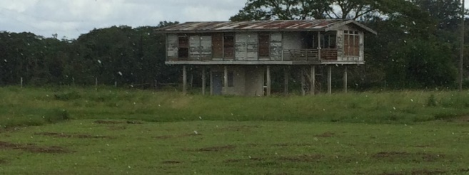 | 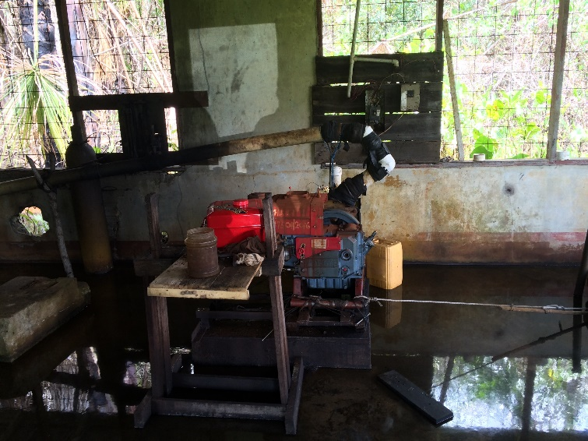
Plate 1. State of some of the housing and equipment on the Ebini Station

The team saw plots of corn and peanuts. The corn was growing under drip irrigation with water being pumped from a nearby creek. This corn looked quite good showing the ability of the savannahs to support viable crop production with proper water management. The Peanut was younger and was not yet being irrigated.

Table 1 Monthly rainfall (mm) for the Ebini Station over the last 10-year period 2006-2015 (Metservices, Guyana 2016)
Station Name: Ebini Element: Monthly Rainfall
Year | `Jan | Feb | Mar |  | April | May | June | July | Aug | Sept | Oct | Nov | Dec
2006 | 239 | 112.5 | 79 |  | 176.4 | 263 | 356.7 | 215.9 | 103.6 | 87.4 | 75.9 | 139.3 | 164.8
2007 | 130.7 | 50.1 | 148.5 |  | 199.5 | 433.9 | 221.9 | 379.1 | 339.8 | 81.5 | 33.3 | 44.9 | 363.5
2008 | 181.8 | 320.9 | 53.9 |  | 216.3 | 306.9 | 428.9 | 460.7 | 84.9 | 193.8 | 96.9 | 76.8 | 426.9
2009 | 216.9 | 98.3 | 76.9 |  | 145 | 67.1 | 251.8 | 219.9 | 184.6 | 59.5 | 80.9 | 23.3 | 126.9
2010 | 158.2 | 64.4 | 154 |  | 290.7 | 623.2 | 243.8 | 353.8 | 143.6 | 157.1 | 41.4 | 305.9 | 176
2011 | 66.1 | 156.4 | 491.4 |  | 57.7 | 219.8 | 236 | 215.3 | 84.5 | 184.3 | 213.6 | 139.5
2012 | 185.7 | 188.7 | 61.4 |  | 264.9 | 389.9 | 245.5 | 382.2 |  |  | 80.1 | 111.4 | 86.3
2013 | 39.2 | 329.3 | 60.3 |  | 287.6 | 439.7 | 410.4 | 287.9 | 258.4 | 17.8 | 10.7 |  | 265.1
2014 | 116.6 | 172.9 | 154.9 |  | 26.2 | 126.7 | 287.3 | 213.1 | 111.5 |  |  | 156.2 | 108.5
2015 | 163.1 | 102.4 | 99 |  | 122.3 | 275.0 | 228 | 373 | 178.3 | 72.7 | 1.8 | 113.9 | 129.3
 | Missing Data

Figure 1. 30 years Average of monthly rainfall for Ebini (Metservices, Guyana 2016)

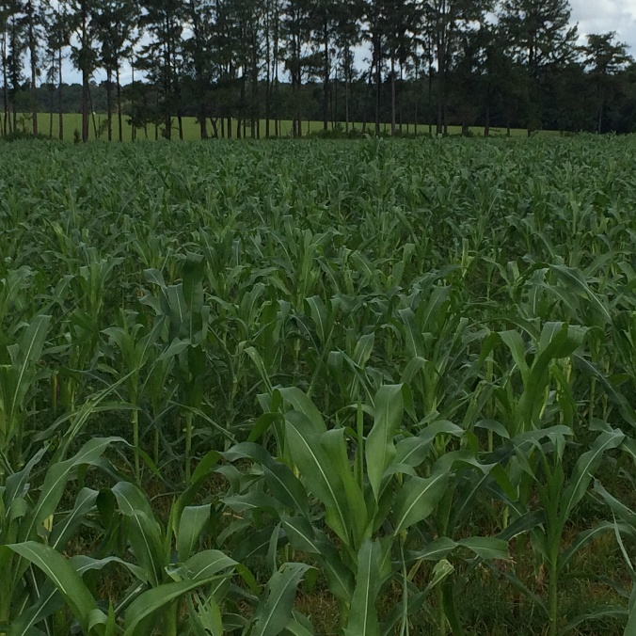 | 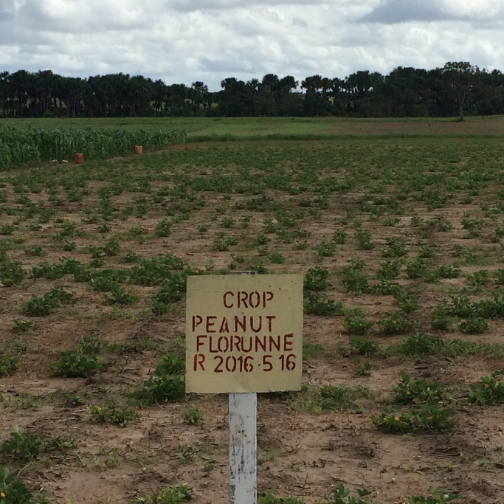
Plate 2. Corn and peanut plots which were growing on the station during the visit

The animals on the station also looked to be in good condition growing on the pastures on the station. At the time of the visit, there appears to be must more forage on offer than the animals could use.

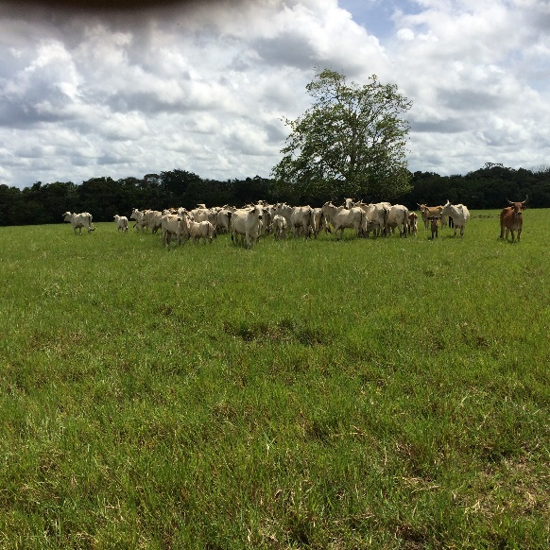 | 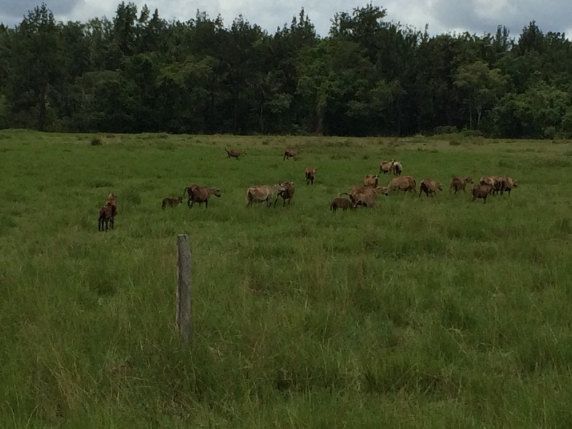
Plate 3. Cattle and sheep grazing on developed pastures on the Ebini Station

Visit to the Rupununi Savannah
The visit to the Rupununi area was made over the period 27 -29 June 2016. The team consisted of Mr Bill Anderson, Mr Kelvin Clarke, Mr Nigel Cumberbatch, Mr George Jervis, Mr Khemlall Alvin, Dr Mark Pierre and Dr Leslie Simpson. The team travelled in by aircraft and were met at Lethem by officials of NAREI and GLDA stationed in the area.

Characteristics of the Rupununi Savannah
The region is approximately 1.3 million ha of open savannahs.
The rainfall pattern is unimodal characterized by five month (April to August) rainy spell followed by a seven month dry season. The climate is considered harsher than in the Ebini area, with lower total annual rainfall and a longer and more severe dry season. Table 2 gives the monthly rainfall for the last 10-year period 2006 -2015, while Figure 2 gives the 30 years Average of monthly rainfall for Lethem, Rupununi (Metservices, Guyana 2016).

Considerably less technical information relating to soil characteristics, climate and other natural resources is available for the region. 21 different soil types have been identified for the area these were combined into four Land Capability Classes (Suggett and Braun, 1964):-
1. Class I-II: Good to Moderate agricultural land – 170 sq. miles or 1% of the area
2. Class IIIf: Poor agricultural land with fertilization possibilities – 9,305 sq. miles or 49% of the area
3. Class III: - Poor agricultural land – 5,140 sq. miles or 27% of the area
4. Class IV: - Non-agricultural land – 4,185 sq. miles or 22% of the area

The major limitations for these savannas are similar to those for the Intermediate savannas as far as soil chemical conditions. These are complicated by climate and drainage problems. The climate is much harsher than in the Ebini area, with lower total annual rainfall and a longer and more severe dry season (ISNAR, 1982).

In the Rupununi the predominant agricultural activity has been cattle rearing on natural pastures. Although the total herd population has dwindled to 13,000 head from a reported high of 65,000, there is still a sense that beef ranching remains the main cultural niche of the native population.

Visit to the Region Chairman, Region 9 – Mr Bryan Allicock
The Region Chairman welcomed the members of the visiting team and indicated that the area was mainly cattle producing but production has declined over the years owing to lack of a sustained market. He indicated that a rehabilitated abattoir would go a far way towards re-invigorating the cattle Industry. He also pointed out that the road to Georgetown is to be completed in the next six years and this would provide a further market opportunity for beef coming from the Rupununi

Visit to Santa –Fe Farms
The Team then made a trip to the Santa Fe Farm which was about one hour from Lethem. At the farm the tour was guided by Mr Persaram Ramdat, the farm manager. Although its main crop is rice the Santa Fe Farm produces a wide range of agricultural produce (Plates 4-6). This includes vegetables, root crops and orchard. Although many of these were in semi-commercial quantities, it did indicate the range of possibilities for the area.

The soil management was particularly interesting as it involved the incorporation of livestock manure into the soil profile. This was done by digging pits of about 60 cm deep and mixing the soil with the manure before re-filling the pits. This allow the plants to have more than 60 cm depth of well ameliorated soil. Cassava growth using this system appears to be very prolific (Plate 7). Although this system is manual and likely to be costly, it is possible to do it mechanically. There are no written reports on the productivity of this system and so an assessment of this soil management practice would be included in research proposals for Region 9 and 10.

Table 2 Monthly rainfall (mm) for the Lethem, Rupununi Station over the last 10-year period 2006-2015 (Metservices, Guyana 2016)
Station Name: Lethem Element: Monthly Rainfall (mm)
Year | Jan | Feb | Mar | April | May | June | July | Aug | Sept | Oct | Nov | Dec
2006 | 41.4 | 3.8 | 27.4 | 24.4 | 368.0 | 432.0 | 370.8 | 97.3 | 115.7 | 48.9 | 35.8 | 5.9
2007 | 27.6 | 0.0 | 114.1 | 188.0 | 357.9 | 381.0 | 475.8 | 312.7 | 92.2 | 49.2 | 5.8 | 71.7
2008 | 12.8 | 27.3 | 20.0 | 77.9 | 154.7 | 288.1 | 488.3 | 191.4 | 196.7 | 150.1 | 29.4 | 174.5
2009 | 65.6 | 25.5 | 5.2 | 5.5 | 15.3 | 190.5 | 335.7 | 138.2 | 41.4 | 35.7 | 0.0 | 123.4
2010 | 11.9 | 25.8 | 44.4 | 180.9 | 509.2 | 406.7 | 347.3 | 337.5 | 142.0 | 119.0 | 105.6 | 78.4
2011 | 28.1 | 11.8 | 425.7 | 50.4 | 571.8 | 377.6 | 316.6 | 174.3 | 88.0 | 135.0 | 259.7 | 6.7
2012 | 32.8 | 75.9 | 44.6 | 222.6 | 308.6 | 133.7 | 280.7 | 125.3 | 55.4 | 45.5 | 54.6 | 25.2
2013 | 1.3 | 55.9 | 20.7 | 142.1 | 377.5 | 244.6 | 274.4 | 233.6 | 177.3 | 1.4 | 51.9 | 3.6
2014 | 11.1 | 12.3 | 11.8 | 60.1 | 181.7 | 330.5 | 222.1 | 150.8 | 40.9 | 68.7 | 6.7 | 7.8
2015 | 10.3 | 13.4 | 1.5 | 42.1 | 408.7 | 187.0 | 144.9 | 124.8 | 33.4 | 4.0 | 0.4 | 34.3

Figure 2. 30 years Average of monthly rainfall for Lethem, Rupununi (Metservices, Guyana 2016)

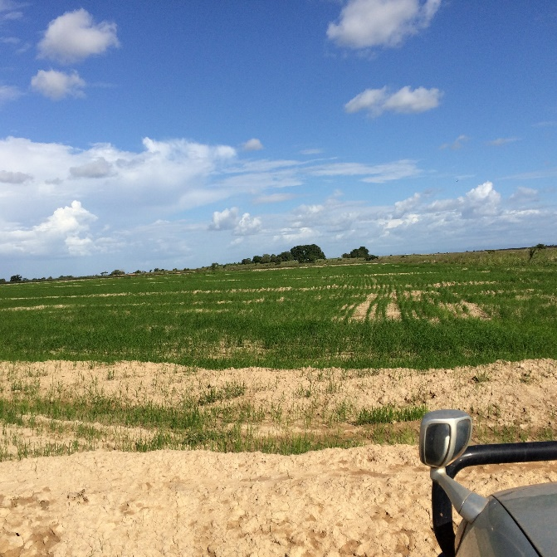 |  | 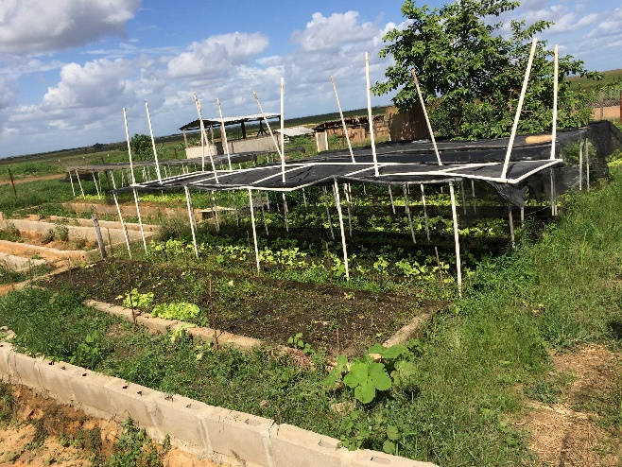
Plate 4. Rice and Vegetable production at the Santa Fe Farm in the Rupununi
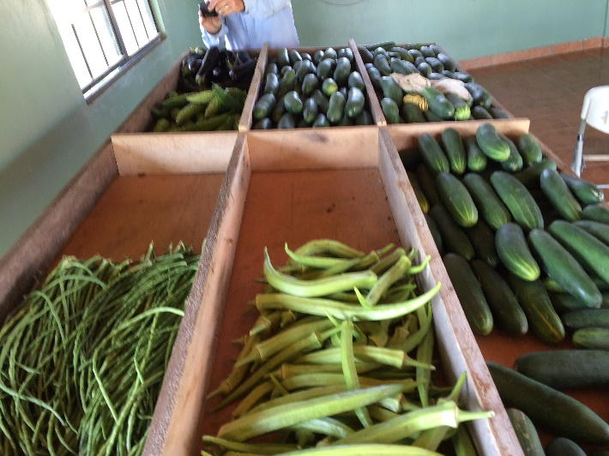 |  |  | 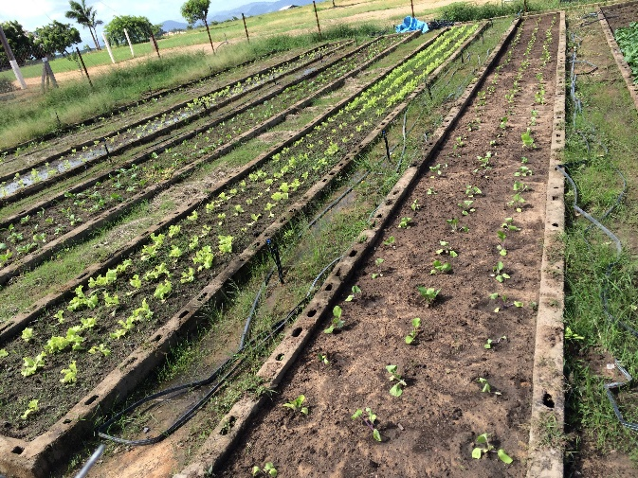
Plate 5. Some of the produce from the Santa Fe Farm |  |  | Table 6.Vegetable beds growing lettuce in soil ameliorated with organic matter
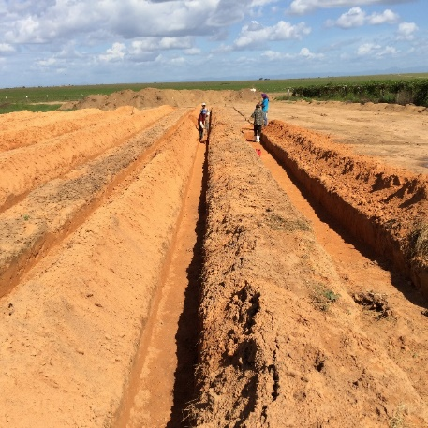 | 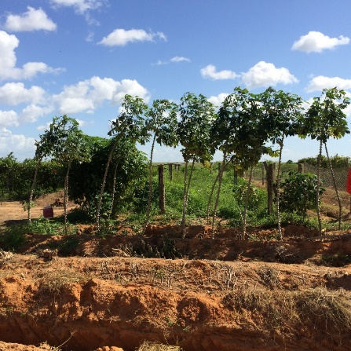 |  |  | 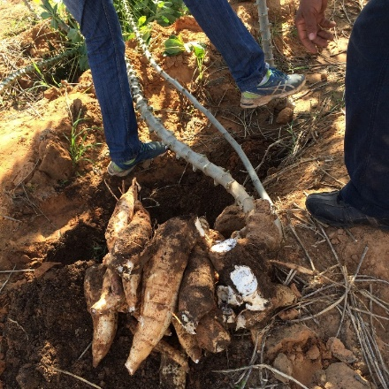
Plate 7. Soil pits for soil amelioration, cassava growing on ameliorated soil and cassava harvest at the Santa Fe Farm

The examples of Santa Fe Farm and the use of similar lands in Brazil indicate that at least in some of the soil types it is possible to grow row crops economically with suitable soil amelioration and fertilization. Orchard crops which are able to better withstand seven months of low rainfall conditions is also a distinct possibility.

Meeting with the Rupununi Livestock Producers Association
The Rupununi Livestock Producers Association (RLPA) appears to be the most vibrant agricultural producer association and its 60 -70 members are beef and small ruminant producers. Their major project is the rodeo which is a tourist attraction for the Lethem area held every year at Easter time. They indicated that the areas was once known for its cattle production, this has seen declined significantly in this last 40 years. They however felt that cattle production could be re-kindled by the provision of a new abattoir to help them market their meat, the introduction of new and improved breeds of animals, expansion of marketing opportunities by the opening of the road to Georgetown. One specific request was the conduct of a cattle industry value chain analysis to help them to understand the various market possibilities of the Industry.

Visit to Brazil
The visit to Boa Vista in Brazil involved crossing the Takutu River Bridge at Lethem into Brazil and included the necessary immigration procedures on both sides. From Bonfim to Boa Vista is approximately 120 Km, but the road was quite good. They were very obvious similarities of soil, vegetation etc between the landscape in the Rupununi and that along the road from Bonfim to Boa Vista.
On the way the team visited a farm which produced bananas, cattle and sheep. This highlighted the diverse agricultural activities that are possible within the area. On the farm, the team also saw fish ponds which were part of a wider water catchment area which provided water resources for the rest of the farm. This concept can be adopted in the Rupununi savannahs to harness and utilize the rainfall in the area.
The team also visited the EMBRAPA Office in Boa Vista, Brazil. EMBRAPA the State agency in Brazil responsible for agricultural research and has research station across the country. The team met with Alioisio Alcantara Vilarinho, the chief of research at the station. He indicated that the station has worked with cassava, corn, cowpea, rice and soyabean to increase their production in the area. In terms of collaboration with the research efforts in the Rupununi area of Guyana, the chief indicated that this will have to be organized at a Government to Government level. An exchange programme with researchers from this Region at EMBRAPA would be a great asset to this programme.
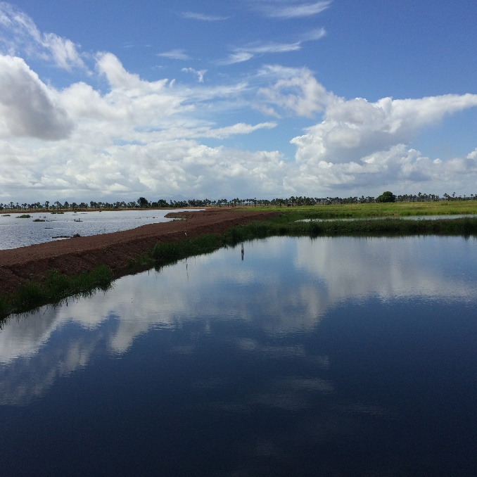 | 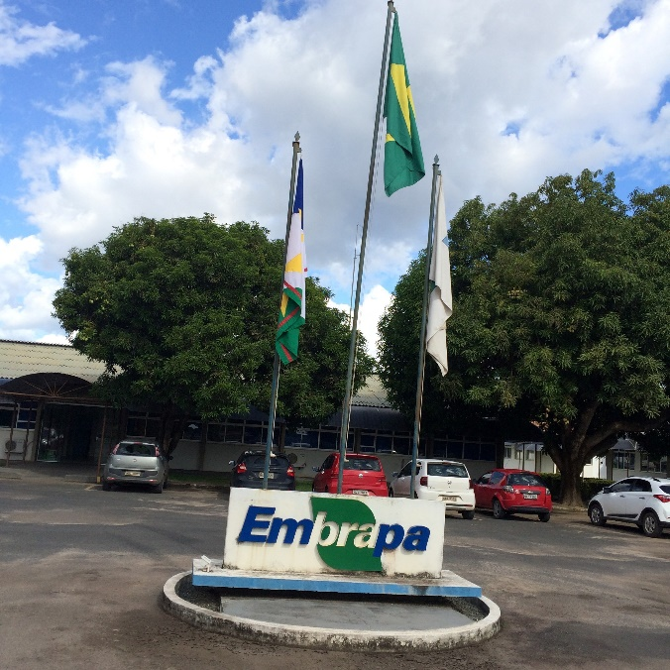
Plate 8. A fish pond and adjoining water catchment area at a farm in Brazil | Plate 9. The EMBRAPA Office at Boa Vista, Brazil

Literature and documents review
The consultant has been provided by a range of documents for view pertaining to component 2 of this programme. Not all of these documents have been reviewed to date but some have been consulted to provide information on the characteristics of the areas of focus and these capabilities in terms of the developing of a proposal for research. The documents which have been carefully reviewed to date are the strategic plans of NAREI and GLDA for the period 2013 -2020

Review of strategic plans drafted by NAREI and GLDA

Strategic plan of NAREI
The Research and Development Strategy is based on a holistic approach to agricultural development in Guyana. It has taken cognizance of the fact that agriculture would continue to be a strategic sector in the Guyanese economy in the long term as a medium for poverty reduction, food security and job creation. Further, it recognizes that agriculture would play a major role in the provision of inputs for other sectors of the economy such as agribusiness and agroindustry.

The objectives of the Research and Development Strategy are to:
1. Generate, develop and apply new knowledge and technology for agriculture;
2. Ensure sustainable use of natural resources;
3. Enhance nutrition, food security and safety;
4. Enhance the ability of the agricultural sector to manage and mitigate agricultural risks;
5. Commercialize research results; and
6. Achieve support services excellence

Under each of these strategic objectives expected results, programmes and projects have been developed. This is a very exhaustive list of activities that are anticipated for the period 2013 – 2020.
A review of this list indicates some activities which fit within the ambit of this programme and are recorded here to demonstrate the synergies between the research strategy and the research proposal to be developed under this programme

Strategic objective 1. Generate, develop and apply new knowledge and technology for agriculture

Expected results
Enhanced Food Security

Programme
1. Hinterland & Savannah Development

Projects
- Identification of suitable areas away from the coast for fruit and vegetable production.
- Expanding cashew nut production.
- Identify and improve production of cassava with high starch content for processing.
- Introduction of large scale soybean cultivation.
- Testing, validating and dissemination of appropriate agricultural production systems for the savannahs.

Programme
2. Value added production.

Projects
- Post harvesting handling.
- Processing of perishables using solar drying technology.
- Small scale agroprocessing

Strategic Objective 2: Ensure sustainable use of natural resources;
Expected Results
Efficient utilization of natural resources for improved agricultural productivity.

Programme
1. Improved management practices to reduce soil degradation.

Project
- Liming
- Mulching
- Cover Cropping

Programme
2. Organic agriculture

Projects
- Slash and mulch
- Use of plants with pesticide properties
- Vermicomposting
- Training Conservation agriculture
- Agro-forestry practices
- Reduced tillage

Expected result
Water-use efficiency

Programme
Irrigated fruit and vegetable production

Projects
- Drip irrigation
- Sprinkler irrigation
- Information packages
- Training

Strategic Objective 3: Enhance nutrition and food safety

Expected result
Increased access to and availability of quality and safe nutritional food.

Programme
Acquisition of new and improved cultivars and use of appropriate animal breeds.

Project
1 Crop and animal improvement (through acquisition of breeding stock) and production practices.

Strategic Objective 4: Enhance the ability of the agricultural sector to manage and mitigate agricultural risks

Expected result
Provision of products and services relating to climate change and its impact.

Programme
- Modelling of natural resources for agricultural production.

Projects
- Effect of irrigation on agricultural production.
- Water user efficiency for agriculture.

Programme
- Climate change and agricultural risk and management.

Projects
- Development of adaptation and mitigation strategies (improved seedling production, greenhouse technology).
- Promotion of hinterland agriculture

The NAREI strategy also indicated the necessity of transfer the technologies developed to the beneficiaries. It stresses the need for an efficient and effective extension services. In this regard, the strategy states that “The MOA has re-organised the Extension Service in order for it to become more efficient and responsive to the needs of the farming community” and that the Extension Services Unit (ESU) would be intimately linked with NARI.
The strategy also gives an analysis of the strengths, weaknesses, opportunities and threats (SWOT Analysis) of the Institute in embarking on the Research and Development Agenda 2013 -2020. This analysis is reproduced here in Chart 1.

The strategy indicates that the greatest weaknesses are the lack of trained manpower in specific disciplines such as biotechnology, inability to attract and retain staff and inadequate use of resources, and an inadequate extension services to transfer technology. In terms of the challenges related to staff the strategy does indicate under the discussion on staffing that it intends to pursue some definitive actions to alleviate these challenges. These actions include:
- Developing partnerships with local institutions such as UG, GUYSUCO, IAST and GRDB
- Developing formal relationships with international institutions such as EMBRAPA, CIAT, IICA, FAO, as well as relevant institutions in India, China and Cuba
- Post-graduate training in specific areas such as biotechnology, entomology, water management, agroprocessing, agro-energy, etc.

Other weaknesses are lack of adequate office and laboratory equipment, poor inter-agency linkages and a decline in research and development innovations. No reference was found as to how these challenges would be alleviated, except for a reference to the development of a seed laboratory under the Agricultural Diversification Programme (ADP).

CHART 1: SWOT ANALYSIS OF NARI’S RESEARCH AND DEVELOPMENT STRATEGY (2013-2020)
STRENGTHS  - Regional and international recognition of research  - Well trained technical expertise in some areas  - Potential to conduct research and demonstration in all regions of Guyana  - Reasonably good facilities  - Repository of all agricultural research information in Guyana  - Leading institution in agricultural information  - Experience with working in partnership with local and international organizations | WEAKNESSES  - Lack of trained manpower in specific disciplines e.g. biotechnology, agricultural economist, agricultural engineering, etc.  - Inability to attract and retain staff and inadequate use of resources  - Lack of adequate office and laboratory equipment  - Inadequate extension services  - Poor inter-agency linkages  - Decline in research and development innovations
OPPORTUNITIES  - Promotion of agricultural diversification by the GOG.  - Further alliances with local and international research institutions in capacity building and sharing of information  - Specific research needs identified for farming communities based on feedback from the Extension Services Unit.  - Potential to increase activities and output in the regions  - Ability to utilize baseline data for agricultural research, planning and implementation  - Diversify into new areas of crops and livestock research  - Developing partnerships for contract research with the private sector  - Utilizing the agribusiness approach to promote agricultural development  - Appointment of Research Associates and utilizing visiting scientists in identified disciplines | THREATS  - Lack of adequate financial resources to implement programmes  - Rapid staff turnover  - Exports of commodities threatened by international trade regulations  - Rising costs of production  - Change in demographic factors – from coastal to interior locations  - Impacts of climate change  - Adoption of improved technology by farmers.

The strategy also indicates that NAREI plan to initiate an Organizational Performance Assessment System (OPAS) during the 2013 – 2020 period. This approach is described as an internally driven assessment process that is an integral part of research management and is aimed at systematically improving organizational performance. In OPAS, research organizations are assessed as research production systems, in which investment of resources leads to the production of outputs. The systems focuses on the evaluation of these outputs and on analysis of the management processes that influence the production of these outputs, with a view to enhancing the productivity of the system

Strategic plan of GLDA
The Guyana Livestock Development Authority Strategy has its genesis in the Livestock Sector Development Policy. The policy document defines the framework within which Guyana’s development plans in the livestock sector are to be designed and implemented. The strategy operationalizes this policy with a set of plans and research and development initiatives which are geared towards alleviating constraints and challenges to livestock development in Guyana.

The strategy articulates a vision of a vibrant livestock industry, providing safe food to Guyana’s population and generating income for rural and urban households, while making optimal use of available resources and competing with producers beyond its borders.

The Mission of the Guyana Livestock Development Authority is to promote greater efficiency in the livestock and livestock product industry and to enhance services in livestock husbandry, livestock health and research and to make provision for effective administration, for internal competition between industries and regulation of trade, commerce and export of livestock or livestock products.

The vision of the Government of Guyana and the mission of GLDA translate into the following goals:
- Primary production. To enhance livestock production capacity and practice of current and potential livestock keeping households, enabling them to overcome constraints and realize opportunities of available resources, markets and technologies;

- Product chains. To enhance the capacity of enterprises and individuals to provide and improve inputs for livestock production, for marketing and for adding value to primary livestock products;

- Support services. To provide or enhance the accessibility of effective services needed by livestock producers and the livestock industry to improve animal health (Veterinary Services), animal genetic quality (Breeding services), market information (also including export markets) and to define, plan, implement and monitor publicly funded interventions (Development services);

- Regulation. To offer and improve regulations that stimulate livestock production, and enhance the safety of livestock-derived food, the equitable use of resources, and the protection of the environment;

Component 2 of the IDB Loan programme is particularly concerned with the first three goals related to primary production, product chains and support services. Under these three goals various strategic interventions have been developed under various commodity and thematic areas. The various commodity and thematic areas that are considered of importance to the Loan Programme are:
- Cattle production
- Sheep and Goat Production
- Livestock research
- Animal breeding services
- Farmer capacity building

Some of the important strategic interventions in these commodity and thematic areas are:

Cattle Production
Objective 1. To Increase productivity of cattle (milk, beef) resulting in higher incomes for cattle keepers and a higher level of competitiveness compared to imported beef and milk.

Expected Results
- An increased percentage of all cattle inseminations (natural or artificial) done with semen of tested and selected breeding bulls.
- Commercial cattle farmers have adopted husbandry practices that reduce the incidence of calf mortality, prevent diseases, and improve production of quality feed, of feeding, of housing, of milking, of cow reproduction and of farm economics.
- The carcass weight of animals slaughtered at designated abattoirs has increased.
- The average production of milk of cows with farmers selling milk has increased.
- The incidence of cattle diseases is reduced.

Objective 2. To expand the production of beef, using inland resources while balancing carbon emissions.

Expected Results
- The area designated for cattle production in the inland savannahs increased.
- Commercial cattle farmers in the inland savannahs have participated in demonstrations of forage budget planning and forage cultivation on savannah soils, through a system of minimized “carbon footprint”.

Objective 3. To increase the volume and quality of domestic beef and milk available to domestic consumers and export of beef.

Expected Result
- Commercial pasture/feed lot enterprises provide a substantial proportion of slaughtering animals to designated abattoirs.

Sheep and Goat Production
Objective 1. To improve production parameters of small ruminants.

Expected Results
- Holders have increased knowledge about good livestock keeping practices.
- Foot rot and other common disease problems reduced as a result of better production systems.
- Small ruminant farmers institute a breeding season with births occurring in the dry periods of the year.
- The growth parameters and carcass weight increase.

Objective 2. To increase the availability of mutton offered for a competitive price.
Objective 3. To increase the export to CARICOM countries.

Expected Result
- A sub-group of the association of small ruminant’s holders has the capacity and experience to export mutton

Animal Breeding services
Objective 1. To increase the availability of bulls and heifers of superior genetic quality.

Expected Results
- A well-articulated and commonly agreed cattle (milk/beef) breeding policy guides investments and choices for development.
- A subpopulation of selected potential bull mothers (PBMs) produces breeding bulls.
- Bull testing and/or cattle breeding centres have been established at three locations (the coast, the Intermediate Savannahs and the Rupununi Savannah) a bull rotation program provides superior bulls to cattle farmers on a breeding cycle basis.

Objective 2. To increase the number of calves born through artificial insemination using semen of tested and selected breeding bulls.

Expected Results
- Inseminators, Breeding Technicians and selected farmers (in remote areas) deliver efficient AI services.
- Infrastructure for the service available and well maintained
- Shoat 'multiplier instrument'

Objective 4. To increase the number of lambs and kids born through (natural and artificial) insemination using breeds and individual rams/bucks of desired superior traits.

Expected Results
- A sheep/goat breeding policy has been formulated in a participatory manner, and guides GLDA support to breeding services.
- Commercial nucleus flocks produce good quality rams/bucks, as well as ewes/does to meet a demand.
- New and current holders of sheep and goats can access superior animals through a “shoat multiplication scheme”.

Livestock research
Objective 1. To study, assess and demonstrate sustainable forage and grazing systems at the intermediate savannahs and at the Rupununi savannah.

Objective 2. To study, assess and demonstrate sustainable cultivation and harvesting practices for fodder maize, sorghum and soya at the intermediate savannahs.

Objective 3. To provide laboratory services to farmers, extension staff, inspectors and other stakeholders for testing feed quality, milk quality, and contaminants in feed and food.

Farmer capacity building
Objective 1. To develop, document and extend Best Practices for livestock husbandry, fodder production, animal health, marketing and farm management to perceptive farmers.

Expected Results
- Farm-economic data for the major livestock production systems, involving stakeholders as partners, are prepared on an annual basis and guide the identification of practices that are better than average.
- Technical benchmarking parameters of the major livestock production systems are collected and analysed involving stakeholders as partners, on an annual basis and guide the identification of practices that are better than average.
- Forage feeding and production systems developed, refined for ruminants in all production areas.
- Extension agents assist farmers to remove obstacles, use opportunities, or solve problems within their sphere of influence related to animal production and rural livelihoods.

Objective 2. To maintain a high level of knowledge, analytical and communicative qualities of the extension staff.

Feasibility of long term plan and identification of potential beneficiaries
The long term plans as set out by NAREI and GLDA are quite comprehensive and clearly detail a vision for the agricultural development of the Savannah areas of the country. The opening-up of these areas for sustainable agriculture development would however require an expansion of the country’s infrastructure to provide adequate social services in these areas. The Ebini Station will require better road access, more reliable river transport and possibly a regular flights to the area. There are plans to strengthen the road link to Georgetown to Lethem and this will be a boost to the agricultural development possibilities in the Rupununi area. An inadequate transport system will hamper social and economic development by increasing production costs and, therefore, reducing competitiveness of commodities and products. This is clearly an area in which an integrated approach to agricultural development utilizing private/public partnerships may provide useful results. Since it may be extremely difficult for the government to initially provide and maintain road links to the savannhs, this may be more possible with support from medium to large enterprises operating in the area.

The documents clearly define the beneficiaries of the agricultural development in the savannah areas. These are the large to medium size agricultural producers who are willing to invest in the area, the farming communities already in the area, as well as exporters, agro-processors, etc. who will benefit directly through enhanced livelihoods. This development will also strongly support the Agriculture Ministry’s focus on food security for the general population. The benefits will further extent to the economy of the country and ultimately to all of its citizens.

Analysis of gaps and requirements based on long term vision developed by NAREI and GLDA.
The NAREI strategy clearly indicates that there is a severe lack of trained manpower particularly in specific disciplines such as biotechnology and this is compounded by an inability to attract and retain staff. The Professional staff complement at both Ebini and Rupununi are inadequate to carry out the envisioned research and Development work. This is an important gap to be noted and addressed if the programme is to be successful.

Coupled with the human resources capacity is the infrastructural capacity which must be enhanced as well. The strategy mentions the poor state of infrastructure and this was also seen particularly at Ebini. At Rupununi there is no functioning station and so there will be need for the development of a full station with all the necessary infrastructure. At Ebini rehabilitation works are required to upgrade the infrastructure as well as enhancement works to modernize the equipment and facilities on the station.

An important part of the infrastructural development at both locations must be the provision of a reliable water supply for both domestic (including processing) and irrigation needs. At Ebini there are various creeks which presently supply water to the station. These creeks however do not persist during long dry periods. In the Rupununi, there is likely to be excess water during the rainfall period but a serious deficit in the dry period. In both places there is therefore a need to provide some form of on-station water storage.

Infrastructure in relation to roads was discussed at the higher level in the previous section. With respective to the programme, the maintenance of the roads and the compound for the two stations will have to be considered. Added to this the staff and workers at the station will need to be transported to their various work sites. This will involve the purchase of suitable road vehicles as well as a boat for river transport particular at Ebini.

There also technical infrastructural gaps in order to carry out the research programmes. In particular the poor state of agricultural soil and plant tissue testing facilities in the country needs to be addressed. It has been reported that the Analytical laboratory administered by the Guyana Sugar Corporation (GUYSUCO) is geared to handle the analytical needs of all the agricultural agencies, however this is never realized in practice. The consultant will have to contact GUYCUCO on his second visit to do some assessment of its soil and plant tissue analytical capability. However, to ensure its ability to support scientifically sound agricultural research, NAREI needs to strengthen it capacity and capability to carry out its own soil and tissue analysis. This will entail rehabilitation of the soil and tissue analytical capacity at its Headquarters and acquiring requisite staff to support the laboratory.

Another important technical infrastructural gap is the inability of the sector as a whole to obtain reliable forecasting and early warning information on weather and climate to support it. Although, the National Hydrometerological Service is within the Ministry of Agriculture, its service is mainly to aviation and general weather forecasting. There are various products which are being developed by the CIMH in Barbados to support agriculture and other sectors across the Caribbean. To better utilize these product the human and physical capacity of National Hydrometeorological Service needs to be suitably enhanced.

Proposed Research and Extension Programme for the IS and RS
Based on the vision for the development of the savannahs areas of Guyana as expressed by the Ministry of Agriculture, NAREI and GLDA. There is a definite need to develop the research and extension capacity in the Ebini and Rupununi areas. This is necessary to support the large scale production of selected agricultural commodities.

The production is envisaged through the investment of medium to large enterprises in the production, processing and marketing of these commodities. This investment will be promoted by the production of investment packages for those who may wish to invest in the Savannahs. However, the development of these investment packages require strong research data all of which is not available at the present time.

The production also has a role for the small producer who are presently producing in the communities adjacent to the savannahs. These are riverian areas of the Berbice River and the foot hills of the Rupununi savannah. The larger producers will serve as the market for the small producers in the “Hub and Spoke” model mentioned before. This approach links the small producers as out growers to larger farm and/or processing agribusinesses. This system exploits the scale advantages and management capacity of formal firms that may not be easy to replicate at smaller scales. The system is not new to Guyana and operated in the meat poultry industry. In Africa, cassava production for beer manufacture follows as similar system with the larger producers providing added services for the smaller producers such as:
- Managing the cassava supply from the small producer units
- Developing the agri skills of the smaller producers
- Providing on the ground advice to the smallholder farmers and overviewing the cassava production at critical stages
- Assisting with inputs as necessary
The research and extension activities of NAREI and GLDA will provide innovative technologies and support to the production activities of both the large and small producers in the system.

Another important aspect of the research programme as envisioned by the MoA, NAREI and GLDA is the provision of formal training at the Tertiary level to young people in the two areas. This is important for the future development of trained personnel from these areas for the long term support to the productions systems being developed. The agricultural stations at both Ebini and Rupununi are to be provided with facilities for the training of students from the University of Guyana (UG) and the Guyana School of Agriculture. These facilities include accommodation and modern teaching aids. These training facilities will, of course, be available for the on station training of producers.

Technical support to this proposed Research and Extension Programme for the IS and RS must come from external agencies. This support is envisaged through the provision of technical personnel for varying periods to the two agricultural stations. FAO and IICA in Guyana are amenable to this idea, but the requests will have to come from Guyana Government. Similarly, the vast experience available in Brazil for the management of the savannah ecosystem will be invaluable to the successful implementation of the programme. Again this request will have to be made through the Government of Guyana.

Based on the visions, visits, tours, meetings, and reviews indicated above and a full analysis of all that was seen and heard, the consultant has developed a general proposal for research and extension in the Intermediate Savannahs and Rupununi Savannahs of Guyana. This proposal is being presented in this report as a first step in the process. After discussions with the stakeholders it is hoped this general proposal can be finalized and be given more specific details.

Intermediate Savannahs
The intermediate savannas are characterized by rolling to gently rolling topography, and range in vegetation cover from open savanna to a rather sparse scrub savanna with what appears to be typical forest subclimax vegetation.

The soils are mostly coarse-textured, ranging from sands to sandy loams, and are characterized by low cation-exchange capacity, high percent aluminium saturation, low base saturation, and low available phosphorus and most of the other nutrients. They are low in organic matter and structurally highly unstable.

The climate is hyperthermic with an annual rainfall reported to be 2,250 mm, distributed in a bimodal pattern with the main wet season from April to September and the driest period in October. There is another dry season in February and March.
Important constraints to crop production are:

The prevailing conditions in the savannahs point to the need for a ley cropping system in which crop and livestock farming are integrated and orchard crops are the main component of the cropping system. Annual cropping because of its rapid destruction of the fragile soil system should be restricted to intercrops within developing orchard crops and in areas where specific measures are taken to enhance soil water and nutrient content by incorporating special soil amelioration measures such as biochar, live mulches and agroforestry systems.

To support this system of integrated farming there are priority areas of research which are essential in each of the components. Four broad areas of research are suggested as follows:
- Perennial crops (Orchard crops) Research
- Feeds and feeding systems Research
- Livestock Research – Breeds and breeding
- Soil management

More details of each of these project areas are provided below:
Perennial crops (Orchard crops) Research
- Promote the commercial production of selected orchard crops in the Intermediate savannahs
Crops of Interest are: Avocado, Citrus, Coconut, Papaya, Passion Fruit, Pineapple, Soursop and Water melon

Objectives:
- To select crop species and cultivars with high general and specific adaptability for the Intermediate Savannahs which can generate economic benefits to farmers greater than that produced by existing species/cultivars.
- To include cultivar resilience to climate change in the selection process
- To produce and distribute adaptable, high yielding seeds, seedlings and planting material to the farmers and producers.
- To develop and extend appropriate technologies for production of selected Orchard crop species in the Intermediate Savannahs.

Expected Outputs
- Identified target crop species of the Orchard crops of interest
- Seeds and seedling production of the identified orchards crop species
- Information products for the production of orchard crop in the savannah areas

Details of the studies to be carried out in this research area at Ebini are given below (Table 3)
Table 3. Studies on Perennial and Orchard Crops
Species | Varieties | Sources of genetic material | Research methodology |  |  | Staff requirements
 |  |  | Experimental design | Variables to be measured | Tools to collect the data | Professional staff | Support Staff
Avocado | Choquette  Day  Golden  Hall  Pollock | Florida | 5X5 RCB  4 Varieties  5 Replications  Total of 20 plots  Plot size = 20m x 20m  Exp. Size 1.25 ha | Height of plants (monthly)  Time to first flowering  # of fruits  Crop yield (kg/ha) | Measuring stick  Hanging scale  Weighing bags | Agronomist (1/4 Time)  Biometrician (2 days) | Research technician (1/2)  Labourers (2)
Citrus  - Orange  - grapefruit | Valencia  Ortanique | Trinidad | 2X5 RCB  2 Varieties  5 Replications  Total of 20 plots  Plot size = 20m x 20m  Exp. Size 1.25 ha | Height of plants (monthly)  Time to first flowering  # of fruits  Crop yield (kg/ha) | Measuring stick  Hanging scale  Weighing bags | Agronomist (1/4 Time)  Biometrician (2 days) | Research technician (1/2)  Labourers (2)
Coconut | Local varieties |  | 4X4 RCB  4 Varieties  4 Replications  Total of 16 plots  Plot size = 40m x 20m  Exp. Size 1.30ha | % Ground cover/ DAP  Time to first flowering  Crop yield (kg/ha) | Digital Camera  Hanging scale  Weighing bags | Agronomist (1/4 Time)  Biometrician (2 days) | Research technician (1/2)  Labourers (2)
Papaya | Maradol  Sunrise  Caribbean Red | Belize | 4X5 RCB  4 Varieties  5 Replications  Total of 20 plots  Plot size = 20m x 20m  Exp. Size 1.25 ha | Height of plants (monthly)  Time to first flowering  # of fruits  Crop yield (kg/ha) | Measuring stick  Hanging scale  Weighing bags | Agronomist (1/4 Time)  Biometrician (2 days) | Research technician (1/2)  Labourers (2)
Passion Fruit | Mucco  Pintado  Mirim  Redondo | Brazil | 4X5 RCB  4 Varieties  5 Replications  Total of 20 plots  Plot size = 12m x 12m  Exp. Size 0.45 ha | Vine coverage  Time to first flowering  # of fruits  Crop yield (kg/ha) | Digital camera  Measuring stick  Hanging scale  Weighing bags | Agronomist (1/4 Time)  Biometrician (2 days) | Research technician (1/2)  Labourers (2)
Pineapple |  |  | 4X5 RCB  4 Varieties  5 Replications  Total of 20 plots  Plot size = 12m x 12m  Exp. Size 0.45 ha | Ground coverage  Time to first flowering  # of fruits  Crop yield (kg/ha) | Digital camera  Hanging scale  Weighing bags | Agronomist (1/4 Time)  Biometrician (2 days) | Research technician (1/2)  Labourers (2)
Soursop | Brazilian  Local  And other varieties | Brazil | 4X5 RCB  4 Varieties  5 Replications  Total of 20 plots  Plot size = 20m x 20m  Exp. Size 1.25 ha | Height of plants (monthly)  Time to first flowering  # of fruits  Crop yield (kg/ha) | Measuring stick  Hanging scale  Weighing bags | Agronomist (1/4 Time)  Biometrician (2 days) | Research technician (1/2)  Labourers (2)
Water melon | Jubilee  Royal sweet  And other varieties |  | 4X5 RCB  4 Varieties  5 Replications  Total of 20 plots  Plot size = 12m x 12m  Exp. Size 0.45 ha | Ground coverage  Time to first flowering  # of fruits  Crop yield (kg/ha) | Digital camera  Hanging scale  Weighing bags | Agronomist (1/4 Time)  Biometrician (2 days) | Research technician (1/2)  Labourers (2)

Feeds and feeding systems Research
- Pasture research
  - Introduction and evaluation of forage grasses and legumes

Objectives:
- To introduce into the Intermediate Savannahs forage species with high nutrition quality and adaptability to the ecozone
- To select forage species which can provide better quality and quantity of forage to grazing animals than those presently available.
- Develop and provide planting material of selected forage species to the farming community
- To develop and extend appropriate technologies for production of selected forage species to the farming community.

Expected Outputs
- Identified species of good quality grass and legume forage species for the Intermediate Savannahs
- Plant material for the selected grass and legume forage species
- Technological packages for the development of grass and legume forage pastures in the Intermediate Savannahs

- Byproduct Feed research
  - Assessing the use of the byproducts of crop production and processing as feed stock.

Objectives:
- To produce high quality livestock feeds from the byproducts of crop production
- To test the relative performance of various byproduct feeds on the performance of select livestock species in the Intermediate savannahs

Expected Outputs
- Identified high quality byproduct feeding material from the Intermediate Savannahs crop programme
- Facility established for the production of byproduct feeds
- Facility established to carry out feeding trials

Details of the studies to be carried out in this research area at Ebini are given below (Tables 4 and5)
Table 4. Studies on forage grasses and legumes
Species | Varieties | Sources of genetic material | Research methodology |  |  | Staff requirements
 |  |  | Experimental design | Variables to be measured | Tools to collect the data | Professional staff | Support Staff
Grasses  Evaluation of local/adapted forage species in the IS to animal gain and acceptance | Bracharia spp.  Panicum spp | USA/Brazil  Jamaica | 3X4 Factorial  Species - 3  cutting intervals - 4 (3, 4, 5 and 6 weeks)  Plot size 8m X 8m  Exp. Size – 0.12 ha | Above ground biomass (kg)  Leaf:stem ratio  Nutrient quality of forage, animal weight gains | Quadrant  Grass clipper  Bags  Hanging Scale  Chemical analysis of Forage, weight of animals | Pasture agronomist (1/3)  Livestock scientist (1/2) | 1 Research technician (1/2)  Labourers (2)
Legumes Evaluation of adapted pasture legume species in the IS to animal gain and acceptance | Stylosanthes spp.  Arachis spp.  Centrosema spp.  Desmodium spp. | Brazil,  CIAT  Florida | 4X3 Factorial  Species - 3  cutting intervals - 3 (4, 5 and 6 weeks)  Plot size 8m X 8m  Exp. Size – 0.12 ha | Ground cover at 4, 8, 12 weeks  Biomass yields accumulated over 12 weeks  Sward density  Nutrient quality of forage, animal weight gains | Digital Camera  Quadrant  Grass clipper  Bags  Hanging Scale  Chemical analysis of legumes, weight of animals, acceptance of animals | Pasture agronomist (1/3)  Livestock scientist (1/2) | Research technician (1/2)  Labourers (2)

Table 5. Studies on byproduct feeds
Assessment of by product feeds | Types of byproduct feeds | Test animals | Research methodology |  |  | Staff requirement
 |  |  | Experimental design | variables to be measured | tools to collect the data | Professional staff | Support Staff
Utilization of crop by product feeds on the liveweight gains of animals | Feed by products from savannahs, cassava, corn stalks, stover, skins  fruit pulp  legume shells  Commercial feed (control) | Cattle/sheep | 4X6 RCB  Feeds 4  Replicates 6  (2 animals per Treatment)  Total 48 animals  Pens space 48m² | Initial Weights of animals  Weekly Weights of animals  Nutrient content of feeds  Computed cost of each feed | Pens  Hanging Scale  Chemical analyses of feeds | Livestock Scientist (1/2) | Research Technician (1)  Labourers (2)

Livestock research
Promote the sustained increased production of livestock in the Intermediate savannahs
Livestock of Interest are: Beef Cattle and small ruminants (Sheep)

Objectives:
- To increase the availability of sufficient numbers of high quality livestock breeding stock
- To distribute high quality livestock breeding stock and semen to the farming community
- To train farmers in the husbandry practices for the production livestock in the Intermediate savannahs
- To address the impact Climate Change on livestock production and vice versa

Expected Outputs
- Identified target breeds and breed types
- A facility established to breed and multiply selected breeds of beef cattle, sheep and goats
- Requisite information products developed for the training of farmers in the production of livestock in the Intermediate Savannahs
- Marketing mechanism for animal genetic resources established and operating in the Intermediate Savannahs

Details of the studies to be carried out in this research area at Ebini are given below (Table 6)
Table 6. Studies on livestock breeds and breeding
Animal Type | Breeds | Origin | Research methodology |  |  | Staff requirement
 |  |  | Desired pure and crossbreds for testing | Variables to be measured | Tools to collect the data | Professional staff | Support Staff
Cattle | Brahman, Beefmaster, Brangus  Native |  | Brahman/Native  Beefmaster/Native  Brangus/ Native  Pure bred | Liveweight:  at birth, and ADG up to a year. Every 28 days: | Calf pens  Hanging and platform scales, pregnancy scanner, corral, chute, programme to analyze data | Livestock scientist (1/2) | Research technician (1)  Labourers (2)
Sheep | Barbados Blackbelly |  | Barbados Blackbelly on different forages | Liveweight:  at birth and ADG up to a year. Every 28 days: | Sheep pens  Hanging and platform scales, pregnancy scanner, corral, chute, programme to analyze data | Livestock scientist (1/2) | Research technician (1/2)  Labourers (2)

Soil management
- Remove key constraints to crop production through soil/plant environmental modification in the savannahs
Ameliorating practices to be used: Liming, Biochar addition, organic matter addition and agroforestry systems

Objectives:
- To assess the efficacy of selected soil amelioration practices on soil productivity on the acid, infertile and drought prone soils of the Intermediate Savannahs.
- To sensitize farmers to the benefits of using appropriate soil amelioration practices and teach them to use these practices.
- To assess the level of soil carbon sequestration possible through the widespread use of biochar in agricultural production in the Savannahs

Expected Outputs
- Specific soil management practices developed for the appropriate management of the soils of the Intermediate savannahs
- Information products developed for the management of the soils of the Intermediate Savannahs
- Estimates of soil carbon sequestration made for possible Carbon trading

- Evaluation of optimum soil fertility management level for selected crops
Determining the optimum NPK and trace nutrient levels required for optimum performance of selected Orchard and row crops.

Objectives:
- To assess the required fertilization levels the soil of the intermediate Savannahs to support optimum growth and production of selected crop types.
- To sensitize farmers to the benefits of using optimum fertilizer levels for efficiencies in crop production and extending this technology to them.
- To demonstrate the efficient use of fertilizers on farmers’ fields

Expected Outputs
- Specific fertilizer application rate developed for crops such as cowpea, soyabean and orchard crops for optimum production on the soils of the Intermediate savannahs
- Information products developed for the fertilization of specific crops grown on the soils of the Intermediate Savannahs
- Farmers adoption of the technology for efficient fertility management of crops in the Intermediate Savannahs of Guyana.

In addition, as a viable research centre an important output of all the research activities indicate above would be research publications in refereed journals as well as conference papers and other publications.

Details of the studies to be carried out in this research area at Ebini are given below (Table 7).
Table 7 Studies on soil and fertilizer management
Soil amelioration | Treatments | Test Crop | Research methodology |  |  | Staff requirements
 |  |  | Experimental design | Variables to be measured | Tools to collect the data | Professional staff | Support Staff
Biochar addition | T1: Biochar – 15, 000kg/ha  T 2: Biochar – 20,000kg/ha  T 3: Control (No treatment) | Corn | 3X6 RCB  3 Treatments  6 replications  Total of 18 plots  Plot size = 10m x 10m  Exp. Size 0.28 ha | % Ground cover/ DAP  Time to 1st flowering  Crop yield (kg/ha) | Digital Camera  Hanging scale  Weighing bags | Soil Scientist (1/4) | Research Technician (1/2)  Labourer (2)
Variety fertilizer trial -Cassava | Two varieties:  -  -  Fertilizer level  -  -  -  Control | Cassava | 4X5 RCB  4 Varieties  5 replications  Total of 20 plots  Plot size = 10m x 10m  Exp. Size – 0.30 ha | % Ground cover/ DAP.  Sampling for Root Wt (5-9 MAP).  Crop yield (kg/ha) at harvest | Digital Camera  Cutlass  Fork  Hanging scale  Weighing bags  (Mechanical harvester) | Soil Scientist (1/4)  Biometrician (2 days) | Research technician (1)  Labourers (2)
Fertilizer trial –Cowpea | Fertilizer level  -  -  -  Control | Cowpea | 5X5 RCB  5 Varieties  5 Replications  Total of 25 plots  Plot size = 10m x 10m  Exp. Size – 0.40ha | % Ground cover/ DAP  Time to 1st flowering  Crop yield (kg/ha) | Digital Camera  Hanging scale  Weighing bags | Soil scientist (1/4)  Biometrician (2 days) | Research technician (1/2)  Labourers (2)
Fertilizer trial-Peanuts | Fertilizer level  -  -  -  Control | Peanuts | 4X5 RCB  4 Varieties  5 Replications  Total of 20 plots  Plot size = 10m x 10m  Exp. Size – 0.30ha | % Ground cover/ DAP  Time to first flowering  Crop yield (kg/ha) | Digital Camera  Hanging scale  Weighing bags | Soil scientist (1/4)  Biometrician (2 days) | Research technician (1/2)  Labourers (2)

Rupununi Savannahs
Considerably less technical information relating to soil characteristics, climate and other natural resources is available for the region. However, it is generally known that striking similarities exist between the soils, climate and vegetation of the region compared to the Roraima State in northern Brazil.

Within the last 20 to 25 years, the Brazilian government has moved decisively to develop agriculture and related industries in Roraima State. This programme was research led with the country’s state agency EMBRAPA, establishing regional research centres throughout the region. Consequently, a number of agricultural production models have been developed, tested and are being used at the commercial level.

In this Region the predominant agricultural activity has been cattle rearing on natural pastures. Although the total herd population has dwindled to 13,000 head from a reported high of 65,000, there is still a sense that beef ranching remains the main culture niche of the native population. The Rupununi Livestock Producers Association (RLPA) appears to be the most vibrant agricultural producer association and its 60 -70 members are beef and small ruminant producers.
Livestock research appears to be the most feasible priority for the Region with pasture and feeding material being the primary area followed by improved breeding efficiencies and breeds. Also of importance but perhaps as support to this programme should be a value chain study of the Rupununi cattle industry to determine the range of products which can emanate from this sector.

The examples of Santa Fe Farm and the use of similar lands in Brazil indicate that at least in some of the soil types it is possible to grow row crops economically with suitable fertilization. Orchard crops which are able to better withstand seven months of low rainfall conditions is also a distinct possibility.

In the Rupununi the research activities are expected to be carried out on farmers’ fields until the research station is developed. This will allow direct transfer of the technology developed. School farms will also be used to carry out this research under the direct supervision of GLDA and NAREI.

For the Rupununi savannahs five broad areas of research are suggested as follows:
- Perennial crops (Orchard crops) Research
- Annual Crops Research
- Feeds and feeding systems Research
- Livestock Research – Breeds and breeding
- Soil management
More details of each of these project areas are provided below:
Feeds and feeding systems
- Pasture research
  - Improving the nutritional level of the livestock through the introduction and evaluation of new forage grasses and legumes species

Objectives:
- To introduce into the Rupununi Savannahs forage species with high nutrition quality and adaptability to the climatic extremes of the area.
- To select forage species which can provide better quality and quantity of forage to grazing animals than the native savannah grasses.
- Develop and provide planting material of selected forage species to the farming community
- To develop and extend appropriate technologies for production of selected forage species to the farming community.

Expected Outputs
- Identified species of good quality grass and legume forage species for the Rupununi Savannahs
- Plant material for the selected grass and legume forage species
- Technological packages for the development of grass and legume forage pastures in the Rupununi Savannahs

Details of the studies to be carried out in this research area at Ebini are given below (Table 8)
Table 8. Studies on forage grasses and legumes
Species | Varieties | Sources of genetic material | Research methodology |  |  | Staff requirements
 |  |  | Experimental design | Variables to be measured | Tools to collect the data | Professional staff | Support Staff
Grasses  Evaluation of local/adapted forage species in the IS to animal gain and acceptance | Bracharia spp.  Panicum spp | USA/Brazil  Jamaica | 3X4 Factorial  Species - 3  cutting intervals - 4 (3, 4, 5 and 6 weeks)  Plot size 8m X 8m  Exp. Size – 0.12 ha | Above ground biomass (kg)  Leaf:stem ratio  Nutrient quality of forage, animal weight gains | Quadrant  Grass clipper  Bags  Hanging Scale  Chemical analysis of Forage, weight of animals | Pasture agronomist (1/3)  Livestock scientist (1/2) | 1 Research technician (1/2)  Labourers (2)
Legumes Evaluation of adapted pasture legume species in the IS to animal gain and acceptance | Stylosanthes spp.  Arachis spp.  Centrosema spp.  Desmodium spp. | Brazil,  CIAT  Florida | 4X3 Factorial  Species - 3  cutting intervals - 3 (4, 5 and 6 weeks)  Plot size 8m X 8m  Exp. Size – 0.12 ha | Ground cover at 4, 8, 12 weeks  Biomass yields accumulated over 12 weeks  Sward density  Nutrient quality of forage, animal weight gains | Digital Camera  Quadrant  Grass clipper  Bags  Hanging Scale  Chemical analysis of legumes, weight of animals, acceptance of animals | Pasture agronomist (1/3)  Livestock scientist (1/2) | Research technician (1/2)  Labourers (2)

Livestock research
Promote the sustained increased production of livestock through improved breeding and breeding techniques in the Rupununi savannahs
Livestock of Interest are: Beef cattle and small ruminants (Sheep and goats)

Objectives:
- To increase the availability of sufficient numbers of high quality livestock breeding stock
- To distribute high quality livestock breeding stock and semen for artificial insemination to the farming community
- To train farmers in the husbandry practices for the production livestock in the Rupununi savannahs
- To address the impact of Climate Change on livestock production and vice versa

Expected Outputs
- Identified target breeds and breed types
- A facility established to breed and multiply selected breeds of beef cattle, sheep and goats
- A facility for collection and storage of semen and artificial insemination
- Requisite information products developed for the training of farmers in the production of livestock in the Rupununi Savannahs
- Marketing mechanism for animal genetic resources established and operating in the Rupununi Savannahs

Details of the studies to be carried out in this research area at Ebini are given below (Table 9)

Table 9. Studies on livestock breeds and breeding
Animal Type | Breeds | Origin | Research methodology |  |  | Staff requirement
 |  |  | Desired pure and crossbreds for testing | Variables to be measured | Tools to collect the data | Professional staff | Support Staff
Cattle | Brahman, Beefmaster, Brangus  Native |  | Brahman/Native  Beefmaster/Native  Brangus/ Native  Pure bred | Liveweight:  at birth, and ADG up to a year. Every 28 days: | Calf pens  Hanging and platform scales, pregnancy scanner, corral, chute, programme to analyze data | Livestock scientist (1/2) | Research technician (1)  Labourers (2)
Sheep | Barbados Blackbelly | Barbados | Barbados Blackbelly on different forages | Liveweight:  at birth and ADG up to a year. Every 28 days: | Sheep pens  Hanging and platform scales, pregnancy scanner, corral, chute, programme to analyze data | Livestock scientist (1/2) | Research technician (1/2)  Labourers (2)

Perennial crops (Orchard crops) Research
Promote the commercial production of selected orchard crops in the Rupununi savannahs
Crops of Interest are: Citrus, Guava, Mango, Passion Fruit and Acai berry

Objectives:
- To select crop species and cultivars with high general and specific adaptability for the Rupununi Savannahs
- To include cultivar resilience to climate change in the selection process
- To produce and distribute adaptable, high yielding seeds, seedlings and planting material to the farmers and producers.
- To develop and extend appropriate technologies for production of selected Orchard crop species in the Rupununi Savannahs.

Expected Outputs
- Identified target crop species of the Orchard crops of interest
- Seeds and seedling production of the identified orchards crop species
- Information products for the production of orchard crop in the savannah areas

Details of the studies to be carried out in this research area at Ebini are given below (Table 10)
Table 10. Studies on perennial and orchard crops
Species | Varieties | Sources of genetic material | Research methodology |  |  | Staff requirements
 |  |  | Experimental design | Variables to be measured | Tools to collect the data | Professional staff | Support Staff
Citrus  - Orange  - grapefruit | Valencia  Ortanique | Trinidad | 2X5 RCB  2 Varieties  5 Replications  Total of 20 plots  Plot size = 20m x 20m  Exp. Size 1.25 ha | Height of plants (monthly)  Time to first flowering  # of fruits  Crop yield (kg/ha) | Measuring stick  Hanging scale  Weighing bags | Agronomist (1/4)  Biometrician (2 days) | Research technician (1/2)  Labourers (2)
Guava | Puerto Rico and Local varieties | Puerto Rico | 4X5 RCB  4 Varieties  5 Replications  Total of 20 plots  Plot size = 12m x 12m  Exp. Size0.45ha | % Ground cover/ DAP  Time to first flowering  Crop yield (kg/ha) | Digital Camera  Hanging scale  Weighing bags | Agronomist (1/4)  Biometrician (2 days) | Research technician (1/2)  Labourers (2)
Mango | Maradol  Sunrise  Caribbean Red | Belize | 4X5 RCB  4 Varieties  5 Replications  Total of 20 plots  Plot size = 20m x 20m  Exp. Size 1.25 ha | Height of plants (monthly)  Time to first flowering  # of fruits  Crop yield (kg/ha) | Measuring stick  Hanging scale  Weighing bags | Agronomist (1/4)  Biometrician (2 days) | Research technician (1/2)  Labourers (2)
Passion Fruit | Mucco  Pintado  Mirim  Redondo | Brazil | 4X5 RCB  4 Varieties  5 Replications  Total of 20 plots  Plot size = 12m x 12m  Exp. Size 0.45 ha | Vine coverage  Time to first flowering  # of fruits  Crop yield (kg/ha) | Digital camera  Measuring stick  Hanging scale  Weighing bags | Agronomist (1/4)  Biometrician (2 days) | Research technician (1/2)  Labourers (2)
Acai berry | Brazilian  Local  And other varieties | Brazil | 4X5 RCB  4 Varieties  5 Replications  Total of 20 plots  Plot size = 20m x 20m  Exp. Size 1.25 ha | Height of plants (monthly)  Time to first flowering  # of fruits  Crop yield (kg/ha) | Measuring stick  Hanging scale  Weighing bags | Agronomist (1/4)  Biometrician (2 days) | Research technician (1/2)  Labourers (2)

Annual Crops
Promote the commercial production of selected Annual crops in the Rupununi savannahs
Crops of Interest are: Cassava, Corn, Peanuts, and Rice

Objectives:
- To select high yielding crop cultivars with general and specific adaptability to the Rupununi Savannahs
- To include cultivar resilience to climate change in the selection process
- To produce and distribute adaptable, high yielding seeds and planting material to the farmers and producers.
- To develop and extend appropriate technologies for production of the selected crop species in the Rupununi Savannahs.

Expected Outputs
- Identified target crop cultivars
- Seeds and planting material production of the identified crop cultivars
- Information products for the production of the identified crop cultivars in the Rupununi Savannah.

Details of the studies to be carried out in this research area at Ebini are given below (Table 11)

Table 11. Studies on the production of Annual Crops
Species | Varieties | Sources of genetic material | Research methodology |  |  | Staff requirements
 |  |  | Experimental design | Variables to be measured | Tools to collect the data | Professional staff | Support Staff
Cassava, | Uncle Mac  Red Stem  MCOL22  CM849 | CARDI  Columbia | 4X5 RCB  4 Varieties  5 replications  Total of 20 plots  Plot size = 10m x 10m  Exp. Size – 0.30 ha | % Ground cover/ DAP.  Sampling for Root Wt (5-9 MAP).  Crop yield (kg/ha) at harvest | Digital Camera  Cutlass  Fork  Hanging scale  Weighing bags  (Mechanical harvester) | 1 Agronomist (1/3)  Biometrician (2 days) | Research technician (1)  Labourers (2)
Corn, | Open pollinated varieties  CARDI C-001 | CARDI/IITA | 5X5 RCB  5 Varieties  5 Replications  Total of 25 plots  Plot size = 10m x 10m  Exp. Size – 0.40ha | % Ground cover/ DAP  Time to 1st flowering  Crop yield (kg/ha) | Digital Camera  Hanging scale  Weighing bags | Agronomist (1/3)  Biometrician (2 days) | 1 Research technician (1/2)  Labourers (2)
Peanuts | Florunner, AK-62  Guyana Jumbo |  | 4X5 RCB  4 Varieties  5 Replications  Total of 20 plots  Plot size = 10m x 10m  Exp. Size – 0.30ha | % Ground cover/ DAP  Time to first flowering  Crop yield (kg/ha) | Digital Camera  Hanging scale  Weighing bags | Agronomist (1/3)  Biometrician (2 days) | Research technician (1/2)  Labourers (2)

Soil management
- Remove key constraints to crop production through soil/plant environmental modification in the savannahs
Ameliorating practices to be used: Liming, Biochar addition, organic matter addition and agroforestry systems
Objectives:
- To assess the efficacy of selected soil amelioration practices on soil productivity on the acid, infertile and drought prone soils of the Rupununi Savannahs.
- To sensitize farmers to the benefits of using appropriate soil amelioration practices and teach them to use these practices.
- To assess the level of soil carbon sequestration possible through the widespread use of biochar in agricultural production in the Rupununi Savannahs

Expected Outputs
- Specific soil management practices developed for the appropriate management of the soils of the Rupununi savannahs
- Information products developed for the management of the soils of the Rupununi Savannahs
- Estimates of soil carbon sequestration made for possible Carbon trading

- Evaluation of optimum soil fertility management level for selected crops
Determining the optimum NPK and trace nutrient levels required for optimum performance of selected orchard and row crops.

Objectives:
- To assess the required fertilization levels the soil of the Rupununi Savanahs to support optimum growth and production of selected crop types.
- To sensitize farmers to the benefits of using optimum fertilizer levels for efficiencies in crop production and extending this technology to them.
- To demonstrate the efficient use of fertilizers on farmers’ fields

Expected Outputs
- Specific fertilizer application rate developed for crops such as peanuts, cassava and orchard crops for optimum production on the soils of the Rupununi savannahs.
- Information products developed for the fertilization of specific crops grown on the soils of the Rupununi Savannahs.
- Farmers adoption of the technology for efficient fertility management of crops in the Rupununi Savannahs of Guyana.

In addition, as a viable research centre an important output of all the research activities indicate above would be research publications in refereed journals as well as conference papers and other publications.
Details of the studies to be carried out in this research area at Ebini are given below (Table 12)
Table 12. Studies on soil and fertilizer management
Soil amelioration | Treatments | Test Crop | Research methodology |  |  | Staff requirements
 |  |  | Experimental design | Variables to be measured | Tools to collect the data | Professional staff | Support Staff
Animal manure addition | T1: OM – 15, 000kg/ha  T 2: OM – 20,000kg/ha  T 3: Control (No treatment) | Corn | 3X6 RCB  3 Treatments  6 replications  Total of 18 plots  Plot size = 10m x 10m  Exp. Size 0.28 ha | % Ground cover/ DAP  Time to 1st flowering  Crop yield (kg/ha) | Digital Camera  Hanging scale  Weighing bags | Soil Scientist (1/4) | Research Technician (1/2)  Labourer (2)
Variety fertilizer trial -Cassava | Two varieties:  -  -  Fertilizer level  -  -  -  Control | Cassava | 4X5 RCB  4 Varieties  5 replications  Total of 20 plots  Plot size = 10m x 10m  Exp. Size – 0.30 ha | % Ground cover/ DAP.  Sampling for Root Wt (5-9 MAP).  Crop yield (kg/ha) at harvest | Digital Camera  Cutlass  Fork  Hanging scale  Weighing bags  (Mechanical harvester) | Soil Scientist (1/4)  Biometrician (2 days) | Research technician (1)  Labourers (2)
Variety fertilizer trial - Soyaben | Two varieties:  -  -  Fertilizer level  -  -  -  Control | Soyabean | 5X5 RCB  5 Varieties  5 Replications  Exp. Size – 0.30ha | % Ground cover/ DAP  Crop yield (kg/ha) | Digital Camera  Hanging scale  Weighing bags | Soil Scientist (1/4)  Biometrician (2 days) | Research technician (1/2)  Labourers (2)
Fertilizer trial-Peanuts | Fertilizer level  -  -  -  Control | Peanuts | 4X5 RCB  4 Varieties  5 Replications  Total of 20 plots  Plot size = 10m x 10m  Exp. Size – 0.30ha | % Ground cover/ DAP  Time to first flowering  Crop yield (kg/ha) | Digital Camera  Hanging scale  Weighing bags | Soil scientist (1/4)  Biometrician (2 days) | Research technician (1/2)  Labourers (2)

Human and infrastructural input to support this research
Ebini Research Station
The present staff complement at Ebini are three professionals. A large increase in staff complement will be required to carry out the proposed research at the station: The proposed research staff complement for the Ebini Agricultural Centre in terms of total needs, personnel already in place and those required is given in Table 13.

Table 13. The proposed research staff complement for Ebini savannahs
Personnel | Needed | In place | Required
Perennial Agronomist | 2 | 1 | 1
Forage Agronomist | 1 | 1 | -
Livestock Scientist | 2 | 1 | 1
Soil Scientist | 1 |  | 1
Research Assistants | 2 | - | 2
Research Technicians | 8 | 3 | 5

Similarly there will be a need to upgrade the physical infrastructure. The required physical infrastructure includes the rehabilitation of buildings at the station, including relevant furnishings. The other infrastructural needs for the station are given in Annex 4.

Rupununi Research Station
At present GLDA has 3 vets and 2 livestock assistants while NAREI has 2 research assistants, one farm manager and 4 extension field assistants at Rupununi. GLDA also has 2 men spraying vehicles for foot and mouth at the bridge from Brazil. There is also a clerk who is shared by both organisations. This staff has to be augmented to support the research needs envisioned. The proposed research staff complement for the Rupununi Agricultural Centre in terms of total needs, personnel already in place and those required is given in Table 14

Table 14. The proposed research staff complement for Rupununi savannahs
Personnel | Needed | In place | Required
Perennial Agronomist | 1 |  | 1
Annual Crop Agronomist | 1 |  | 1
Forage Agronomist | 1 |  | 1
Livestock Scientist | 1 |  | 1
Soil Scientist | 1 |  | 1
Research Assistants | 3 | 2 | 1
Research Technicans | 8 |  | 8

The total number of personnel required at the two locations in relation to agricultural disciplines is given in Table 15.

Table 15. Total research personnel required for Ebini and Rupununi
Personnel | Ebini | Rupununi | Total
Perennial Agronomist | 1 | 1 | 2
Annual Agronomist | 1 | 1 | 2
Pasture Agronomist | - | 1 | 1
Livestock Scientist | 1 | 1 | 2
Soil Scientist | 1 | 1 | 2
Research Assistants | 2 | 1 | 3
Research Technicians | 5 | 8 | 13
There are several options which have been offered to fulfill the deficit in research personnel indicated in Table 15. These options are:
- Secondment of personnel from International research organisations for specified periods and for specific programmes e.g. EMBRAPA, CIAT
- The recruitment of suitably qualified researchers from the Guyanese diaspora in the Caribbean and North America for specified periods and for specific programmes.
- The use of Postgraduate agricultural students (MSc and PhD) from National, Regional and International Universities to carry out specific studies
- The recruitment of extra staff by NAREI and GLDA to carry out these programmes
- The recruitment of requisite staff national and International by the project for the duration of the project.

It appears that a combination of all of these options may be the best fit for acquiring the needed personnel for the programmes at the present time. The fact that the project also encompasses the training of NAREI and GLDA staff will ensure that in the future there will be enough trained and capable researchers to man the programmes.

Other requirement needs of the programme
From the trials which have been detailed there be a need for land, infrastructure, equipment and materials to support the research proposals at the two locations. Details of these requirements are detailed below in Tables 16 and 17.

Table 16. Land and infrastructure to support the research proposals at the two locations
Research Activity | Ebini | Rupununi | Total
Annual crops | - | 2.0ha | 2.0ha
Perennial crops | 8.0ha | 5.0ha | 13.0ha
Forage crops | 0.24ha | 0.24ha | 0.48ha
Byproduct feeds | Sheep pen – 50m² | Sheep pen – 50m²
Animal breeding | Cattle pen -  Sheep pen - | Cattle pen -  Sheep pen -
Corral | Cattle corral  Sheep corral | Cattle corral  Sheep corral
Chute | Cattle chute  Sheep chute | Cattle chute  Sheep chute
Soil management | 1.50ha | 1.20ha | 2.70ha
Total | 9.74ha | 8.44 ha | 18.18

It must however be noted that these are the initial trials and as the work programme progresses there will be need for much larger areas of land to carry out pasture grazing trials and larger commercial crop growing trials.

Table 17. Equipment and material required to carry out the research trials at the two locations
Equipment/material | Ebini | Rupununi | Total
Digital Camera | 2 | 2 | 4
Hanging scale | 2 | 2 | 4
Platform scale | 2 | 2 | 4
Pregnancy scans | 1 | 1 | 2
Weighing bags | 30 doz. | 20 doz. | 50 doz.
Cutlass | 12 | 12 | 24
Fork | 6 | 6 | 12
Quadrant | 2 | 2 | 4
Grass clipper | 6 | 6 | 12
Corral | 2 | 2 | 4
Chute | 2 | 2 | 4
Statistical programme to analyze data | 1 |  | 1

Laboratory services
From the research projects detailed above there is also the need to have laboratory analytical services to carry out required soil and tissue analysis. These analyses will have to be carried in a very equipped functional laboratory where procedures and standards have been developed to International Laboratory standards. For this reason, it is being recommended that adequate sample preparation facilities be developed at the two agricultural centres at Ebini and Rupununi. Soil and tissue samples can then be collected on the stations dried under prescribed conditions and ground. The requisite oven and dried need to carry out this operation are given below Table 18.

Table 18. Soil and tissue sample preparation equipment needed at Ebini and Rupununi
Equipment | Ebini | Rupununi | Total
Soil Oven | 1 | 1 | 2
Soil grinding mill with sieves | 1 | 1 | 2
Tissue grinding mill  With sieves | 1 | 1 | 2
Drying trays | 6 doz. | 4 doz. | 10 doz.

When the prepared samples are taken to Georgetown, two options have been proposed for the carrying out of the laboratory functions. These are the use of the Nation Soil and Tissue Testing facility at LBI or the Soil and Tissue Testing Laboratory at NAREI headquarters at Mon Repos. Both facilities were visited and the following observations made.

- Soil and Tissue Laboratory at NAREI headquarters
At the present time the Laboratory at NAREI headquarters at Mon Repos, is not functioning. The laboratory itself is in a good state of repairs, but it needs several pieces of equipment, materials and supplies to bring it back to functionality. In addition, it is expected that there will be a lead time to train staff to use the new equipment and get the needed process flow back up to adequate levels.
The list of the equipment and chemicals needed by the NAREI facility is given in Annex 5. The total cost of the equipment is calculated at approximately G$3M which is approximately US$15,000.00 while the material cost is G$4.6 or US$23,000.00

- Nation Soil and Tissue laboratory at LBI, East Coast Demerara
The National Soil and Tissue Laboratory at LBI is a fully functioning laboratory with a capacity to do 15,000 soil and tissue samples per year. This capacity is not fully utilized at the present time and the 1000 to 1500 samples expected from the Ebini and Rupununi facilities are not expected to bring this laboratory to full capacity.

As a functioning laboratory the LBI facility is also up to the required International standards. Davis (2006) reported that the 2005 Report from the International Plant Analytical Exchange indicated that the lab’s repeatability and accuracy on 10 elements placed it well within the group of top performing participating laboratories drawn from institutions around the world.

Complete analyses (including trace elements) for the 1500 samples estimated to come from the two research stations will cost approximately G$9M or US$45,000.00. Not all the samples are, however likely to need a complete analysis.

From the above information, it would appear that the programme would be more appropriately serviced by utilizing the National Soil and Tissue Laboratory at LBI to carry out the soil and tissue analyses required, at the costs indicated above.

Details of the Extension Proposal
The Extension component of the programme is intimately linked to the research programme and will be executed as such. The “Hub and Spoke” model mentioned of development envisioned for the savannahs also encompasses a strong extension component. The medium to large producers are expected to be the users of the most modern technologies and practices. While the agricultural centers are expected to be the producers of technology relevant to the local environment and conditions. From these two entities will come the relevant technological practices to be utilized by the smaller satellite farmers. Figure 3 gives a diagrammatical representation of the Extension and training links among the major components of the agricultural production systems for the savannahs

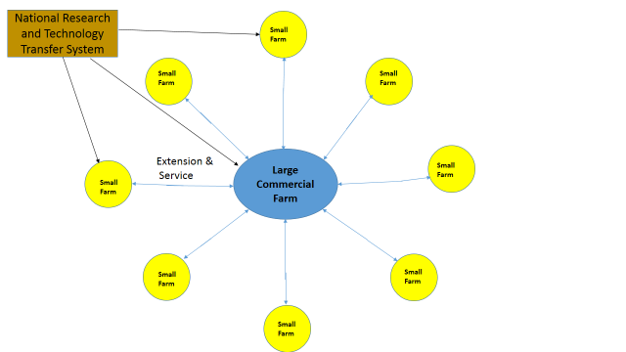
Fig 3. A diagrammatic representation of the “Hub and Spoke” model with support from the National system
The extension system will also encompass a participatory approach to technology transfer and farmer training. This approach will seek to integrate farmer input at all levels of the technology development and transfer system. Farmers would therefore be part of the on-station research e.g. in a corn varietal trial farmers could become acquainted with the various varieties being tested and make inputs related the suitability of particular varieties in relation to plant stature, length of ears from the ground etc. These are practicalities to the farmer which the researcher may not even be aware.

The Farmer Field School (FFS) approach is a widely practiced participatory model that integrates farmers into the technology transfer process. The key to the success of the FFS approach is that it gives farmers the opportunity to not only observe the effects of new technologies on smallholder plots, but also to discover the problems and solutions themselves. In so doing, participants gain skills in training techniques and deepen their understanding of the technical material as well. FFS emphasizes real-time demonstrations in the field with farmer participation rather than lectures citing abstract figures and graphs. Practical application is more consistent with the adult learning skills of smallholder farmers, and it is a method farmers are likely to use themselves in training other farmers.

FFS usually take place in the fields of participating farmers. It’s a school without walls where farmers are not lectured to from books of knowledge; rather, they are given the practical observation and critical thinking skills so that they can use their years of experience to better read the book called their farm (Jaax, undated). The FFS approach would be suitably modified to suite the Guyana context.

In terms of technology transfer to the farming community, a new and exciting means of passing on new agricultural technologies by means of information and communications technologies (ICTs). ICTs include any communication device or application, encompassing: radio, television, cellular phones, computer and network hardware and software, satellite systems and so on, as well as the various services and applications associated with them, such as videoconferencing and distance learning. ICTs are already part of farmer training and this project may be the means of advancing this the use of ICTs in farmer training in Guyana.

An Extension and Training Centres (ETC) will be part of the Agricultural Centres at both The Intermediate and Rupununi savannahs. This centre will be responsible in collaboration with the researchers for the extension components of the proposal and carry out the following functions.
- Development of information products
- Setting up of on-farm demonstration plots
- Farm visits
- On centre farmer training and workshops (FFS)
- On farm training and field days (FFS)
- Monitoring of technology adoption on farms

To carry out these functions each of the extension and training centres will have the following core staff:
- Coordinator (1)
- Snr Crop Extension Officer (SCEO)
- Snr Livestock Extension Officer (SLEO)
- Communications Officer (1)
- Information Technology Technician (1)

The other staff associated with the centre will depend on the particular location

Ebini Extension and Training Centre (ETC)
The Ebini ETC will cater to the Berbice River area and cover all the communities along the river from Torani to Kwakwani and the accompanying savannah areas. There are likely to be1000 beneficiaries in the proposed area. To service this area and carry out the requisite minimum once monthly contact with the farmers will require 12000 contacts per year. These contact will vary from farm visits to field days and on-centre visits. To facilitate the required contacts the proposed area will be divided up in geographic communities or extension areas and assigning officers to monitor each extension area.
The proposed extension areas for Ebini are:
- Torani Sandhills & Ebini (1LEO and 1CEO)
- Kimbia and St Lust (1CEA)
- Wairuni, Calcuni and Tacama (1CEA)
- Eberoba, Kibilibiri, Bamboo Landing (1 LEO)
- Huruni and Kwakwani (1 CEO, 1CEA and 1LEA)
The required staff complement for the extension areas are:
Crop Extension Officers (2)
Livestock Extension Officers (2)
Crop Extension Assistants (3)
Livestock Extension Assistant (1)

Rupununi Extension and Training Centre (ETC)
The Rupununi ETC will manage the North Rupununi Savannah areas. The total beneficiaries will be 2000 farmers in the area. This is areas is about 4 times the size of the Ebini Savannahs and has twice as many clientele. To maintain a similar contact with the farming community extension personnel will have to be resident in the communities to reduce transportation costs.
The proposed extension areas for Rupununi are:
Surama and Karasabi (2CEA and 1LEA)
Lethem, Manari, Pirara and Moco Moco (1CEA, 1LEA and I Veterinary Officer)
Ciranab and Sand Creek (1CEA and 1LEA)
The required staff complement for the extension areas are:
Senior Crop Extension Officers (1)
Crop Extension Officers (2)
Crop Extension Assistants (4)
Livestock Extension Assistant (3)

Table 19. Total extension personnel required for the two locations
Personnel | Ebini |  |  | Rupununi |  |  | Total required
 | Needed | In place | Required | Needed | In place | Required
Coordinators | 1 |  | 1 | 1 |  | 1 | 2
Snr Crop Extension Officer | 1 |  | 1 | 2 |  | 2 | 3
Snr Livestock Extension Officer | 1 |  | 1 | 1 |  | 1 | 2
Communications Officer | 1 |  | 1 | 1 |  | 1 | 2
Crop Extension Officer | 2 | 1 | 1 | 2 | 1 | 1 | 2
Livestock Extension Officer | 2 | 1 | 1 | 1 |  | 1 | 2
Crop Extension Assistants | 3 |  | 3 | 4 | 4 | - | 3
Livestock Extension Assistant | 1 | 1 | - | 3 | 2 | 1 | 1
Information Technology Technician | 1 |  | 1 | 1 |  | 1 | 2

As with the research programme the same options relate to the acquisition of the needed personnel and all these options should be pursued to get the required personnel.

Incentive programme
To increase the likelihood of adoption of improved technologies, and the probability that economic benefits will be observed, the programme will supply a small incentive to implement these technologies. This incentive will be given to small farmers (less than 10 ha) who fit other eligibility criteria for admission to the incentive programme.

The incentives are relatively small and would only cover specific practices in the technological package for a particular commodity. Farmers will select the practice that they want to implement from the technological package for their commodity.

For example, if the farmer is growing blackeye peas in Region 10, the technological package for the growing of this commodity will indicate the cost related to practices such as land preparation, acquiring seeds, planting, acquiring fertilizers etc. The incentive will be geared towards payment for some of the practices for the growing of 1hectare of blackeye in Region 10. Annex 6 gives technological packages for the production of Blackeye, Red peas, Peanuts, Cassava and Orchard crops in Region 10 and these will be used for the determining the incentives for farming involved in these commodities in Region 10.

Recommendations and Conclusion
The broad recommendations reported here relate to the primary objective of the consultancy which is to develop a research program to test, in cooperation with Guyana’s National Agricultural Research and Extension Institute (NAREI) and the Guyana Livestock Development Authority (GLDA), as well as local agricultural extension agencies, an innovative integrated land management approach for sustainable crop/livestock production in the study area, which can be scaled up to the wider region in the future.

In this regard, five broad research areas are recommended as follows:
- Studies on a series of orchard crops to determine the species and varieties best suited to the two locations and in the process determine the agronomic practices required for the sustainable production of the species and varieties and also produce seeds and planting material for the farming community
- Studies on a series of annual crops of interest in the two areas to determine the most adapted varieties, the technological package for their production and also the production of seed and plant material for the farming community
- Studies on a series of grass and legume forage species to determine their nutritional quality, palatability and suitability to the two ecozones, as well as their system of production and use for animal feeding; also in relation to animal feed, studies to test the nutritional quality and palatability of various byproducts of crop production
- Studies on a series of cattle breeds and the black belly sheep to produce higher level genetic stock to the farming community
- Studies on innovative methodologies of soil management including organic matter and biochar amelioration to overcome the physical challenges of the soil; studies on fertilizer management to ensure efficient fertilizer use in crop production

In relation to technology transfer and farmer training three innovative methodologies are recommended as follows:
- The promotion of the symbiotic “Hub and Spoke” model in the savannahs in which among other benefits the larger producer provided improved technologies to the smaller producers
- The use of a more participatory approach to farmer training such as a modified Farmer Field School (FFS) system
- The promotion of the increased use of information and communications technologies (ICTs) in farmer training

In conclusion, there are various recommendation in the body of the report which relate to decisions which have to be taken in relation to efficient execution of the programmes above. These recommendations are too numerous to be recorded here.

Documents Consulted
Ahmad, N. 1989. Acid sandy soils of the tropics with particular reference to the Guyanas. In: Farming systems for low fertility acid sandy soils. D. Walmsley (Ed.).

Cumberbatch R.N.; O. Homenauth; F. Benjamin; A. Leitch; M. Gonsalves A 2015 Protocol for the planting, managing and cost of establishing a fruit orchard in the intermediate savannahs of Guyana. Global Scholastic Research Journal (GSRJ) VOLUME1 ISSUE 12 (November 2015) ISSN: 2349-9397

Davis, H B 2006. GUYSUCO: Agricultural Research Annual Report 2006. (Unpublished)

FAO 1965. Report of the Soil Survey Project of British Guiana. Volume v1. Semi-detailed Soil Survey of the Ebini-Ituni-Kwakwani area. UN Special Fund. Rome 1965

FAO 2014. Final Report – The State of Food & Agriculture in the Rupununi, Guyana. Imperatives for Sustainable Livelihoods and Developmnt. Consultants - Ballayram, Ph.D, Prof. Rory Fraser, Courtney Bullen and Richard N. Cumberbatch. FAO/Conservation International. Georgetown, Guyana

FAO 2014. Integrated Sustainable Agriculture Development Strategy for Region 9 (2015-2020). Consultant Kelvin Craig. FAO/Conservation International. Georgetown, Guyana

FAO 2015 Drought characteristics and management in the Caribbean. FAO Water Reports #42.

GLDA 2013. Guyana Livestock Development Authority (GLDA) The Guyana National Livestock Development Strategy 2013-2020 June 17, 2013

GLDA 2013. Guyana Livestock Development Authority (GLDA) The Guyana National Livestock Development Policy and Strategy Logical Framework (objectives and outcomes) of Strategic Interventions ANNEX 1 to the Livestock Development Strategy 2013-2020. June 17, 2013

GLDA 2013. Guyana Livestock Development Authority (GLDA) The Guyana National Livestock Development Policy June 2013

Government of Guyana (Ministry of Natural Resources and Environment) 2013. Guyana National Land Use Plan. Guyana Lands and Surveys Commission. With assistance from Development of Land Use Planning Project Supported by European Union

Holder, N.L. 1995. Proposals for the Agricultural Development of the Intermediate Savannahs of Guyana. Report of the local Project Coordinator Organization of American States. MoA, Georgetown, Guyana.

IICA 2014. Strategy for Guyana 2014 -2018.

IICA 2014 Water to feed the land / Gertjan Beekman… [et.al].– San José, C.R.: IICA, 2014 xxviii p., 100 p.; 15.2 cm x 22.8 cm ISBN: 978-92-9248-513-9

IICA 2014-2018 Inter-American Institute for Cooperation on Agriculture 2014-2018: Medium Term Plan. Agriculture: opportunity for development in the Americas / IICA – San José, C.R: IICA, 2014. viii, 77 p.; 21 x 16 cm (Official Documents Series / IICA, ISSN 1018-5704; no. 94)
ISBN13: 978-92-9248-538-

International Service for National Agricultural Research (ISNAR) 1982. A Review of the Agricultural Research System of Guyana. 1982. The Hague, Netherlands.

Jaax R (undated). Training & Technology Transfer: Agriculture Technical Transfer through Farmer Field Schools
http://52.0.15.52/sites/default/files/attach/legacy/site/Lookup/WRFallWinter05-Page8-9-TrainingandTechnology/$file/WRFallWinter05-Page8-9-TrainingandTechnology.pdf

Metservices, Guyana 2016. Personal Communications.

NAREI 2013. Strategic Research and Development Agenda (SRDA), 2013-2020. Repositioning Agricultural Research and Development. Compiled by D. P. Singh and O. Homenauth Year of publication: Jan. 2013
www.narei.org.gy

NAREI, 2014. Annual Report 2014. Mon Repos, East Coast Demerara. Guyana.

NAREI, 2016. Effect of Rice Husk Biochar as an Amendment on a Marginal Soil in Guyana. Unpublished Report.

Simpson L A, 1988. Some aspects of soil physical characteristics and their management in the Intermediate Savannahs of Guyana. In Farming Systems for low-fertility acid sandy soils. CTA Seminar Proceedings 5-9 December 1988, Georgetown, Guyana
Suggett, G. and E. Braun (1964). Reconnaissance Soil Survey Report of South-West British Guiana. FAO.

Personnel Consulted
Mr Ashley Adams
Agronomy Research Manager
Agricultural Research Centre
GUYSUCO
aosadams@yahoo.com
ashleya@guysuco.com

Mr Khemlall Alvin
Civil Engineer
Agricultural Support Development Unit (ASDU),
Ministry of Agriculture
e-mail khemlall.alvin@gmail.com

Patrick Chesney Ph.D
Programme Specialist
Environment, Extractive Industry &Energy with responsibility for the Guiana Shield Facility
e-mail Patrick.chesney@undp.org
Skype p.chesney

Mr Nigel Cumberbatch
Chief Executive Officer
Guyana Livestock Development Authority (GLDA)
e-mail richnigcumb@yahoo.com

Garvin Cummings Ph.D
Deputy Chief Hydrometeorological Officer
Ministry of Agriculture
Hydrometeorological Service
e-mail garvin.cummings@gmail.com

Ms Christina Edwards
Secretary
Rupununi Livestock Producers Association (RLPA)
e-mail rupununilivestock@gmail.com

Ms Rebecca Faria
Vice Chairman
Rupununi Livestock Producers Association (RLPA)
e-mail beckyfaria@gmail.com

David Fredericks
Research Scientist
National Agricultural Research and Extension Institute (NAREI)
e-mail fredericks_david@yahoo.com

Mr Wilmot Garnett
IICA Representative
IICA Guyana
e-mail wilmont.garnett@iica.int

Dr Darren Halley
Veterinarian Region #9
Guyana Livestock Development Authority (GLDA)
e-mail dr.halley@yahoo.com

Mr Nizam Hassan
General Manager
Guyana Rice Development Board
e-mail: nhassan@grdb.gy

Oudho Homenauth Ph.D
Chief Executive Officer
National Agricultural Research and Extension Institute (NAREI)
e-mail oudhohomenauth@gmail.com

Mr LeRoy Ignacio
Member
Rupununi Livestock Producers Association (RLPA)
e-mail shulinahleroy@yahoo.co.uk

Mr Ganpat Jaffer
Chief Analyst
Agricultural Research Centre
GUYSUCO
ganpatj@guysuco.com

Mr George Jervis
Permanent Secretary
Ministry of Agriculture
e-mail ps.moagy@gmail.com

Ms Michelle Kenyon
Treasurer
Rupununi Livestock Producers Association (RLPA)
m.kenyon89@yahoo.com

Mr Raymond Latchman
Agricultural Support Development Unit (ASDU),
Ministry of Agriculture
e-mail jerray25@yahoo.com

Ms Sharon Miller
Chief of Operations
Guyana Office
e-mail sharonm@iadb.org

Nall I. Moonilall Ph.D. Student
The Ohio State University
Carbon Management and Sequestration Center
e-mail moonilall.1@osu.edu

Mr Persaram Ramdat
Manager, Santa Fe Farm
e-mail persaram84@yahoo.com

Mr Reuben Hamilton Robertson
FAO Representative
FAO Guyana
e-mail reuben.robertson@fao.org

Aloisio Alcantra Vilarinho
Chief of Agricultural Research and Development
Embrapa Roraima
e-mail cpafrr.chpd@embrapa.br

ANNEXES

ANNEX 1. Agenda Leslie Simpson – First Mission
Monday 20/06 | Conference call with GLDA for introduction and to hear expectations and plan the visit | Phone
Wednesday 22/06 | Travel to Guyana –depart Kingston, Jamaica 2:00 pm –arrive Georgetown 9:35 pm | Caribbean Airlines
Thursday 23/06 | Meetings in Georgetown (NAREI; MoA; GLDA; FAO). Review of existing research; innovation and extension plans. | MoA office
Friday 24/06 | Meetings with key stakeholders, FAO, IICA, UNDP, Hydro-meterological Services
Saturday 25/06 | Travel to Ebini Research Station, Region 10. Meetings with staff discuss research possibilities and do an Inventory of the resources available at the Ebini station | MoA arranged transportation.
Monday 27/06 | Travel to Lethem (regular flight); Visit to Region Chairman – Mr Bryan Allicock, visit to Santa Fe Farm, Visit site proposed for the agricultural center (AC). Meeting with the Rupununi Livestock Producers Association (RLPA)  Do an inventory of physical resources. | MoA facilitated reservations for local airlines and hotel in Lethem.
Tuesday 28/06 | Lethem-Boa Vista. Visit to aquaculture farm. Visit to the to the EMBRAPA station in Manaus | Lethem
Wednesday 29/06 | Return to Georgetown. Prepare draft research programme for presentation to the stakeholders. | Lethem
Thursday 30/06 | Discussions tentative research programs to be financed; tentative requirements for staff, training and equipment. | MoA Office
Friday 1/07 | Meeting with Research Staff, NAREI  Courtesy call to the IDB Office in Georgetown | IDB office; MoA office
Sunday 3/07 | Return to Jamaica 5:35 am | Caribbean Airlines

ANNEX 2. Inventory of the Ebini Agricultural Station

Staff Component
NAREI: 1 Professional
GLDA: 2 Professionals

Land area:

Pasture: Native: 30,000 acres of range
Improved: 3800 acres (Brachiaria humidicola)

Crops: Orchards: 25 acres
Row crops: 10 acres

Livestock: Cows: 450
Sheep: 250

Machinery
Tractors: 2 in good condition, 1 in working condition for pulling trailer, 1 need repairs
Implements: plough 3-disc, harrow 4-row, brush cutter, front bucket, post hole digger
Planter: 1 two-row
Trailers: 3 working condition

Machinery servicing capability: rudimentary

Small equipment: Sprayers: 1 boom sprayer, 1 moto blower, spray cans, fertilizer/lime stone spreader

Support Infra-structure:
Houses: 30 (most in a state of disrepair)
Office: 1 (Need furnishing)
Electricity: Fuel Generator, Distribution system
Telephone: one remote location phone
Domestic water supply: Leaking overhead tank; Old mechanical pump
Internet connection:

ANNEX 3. Soil Mapping Units for Region 9 Rupununi
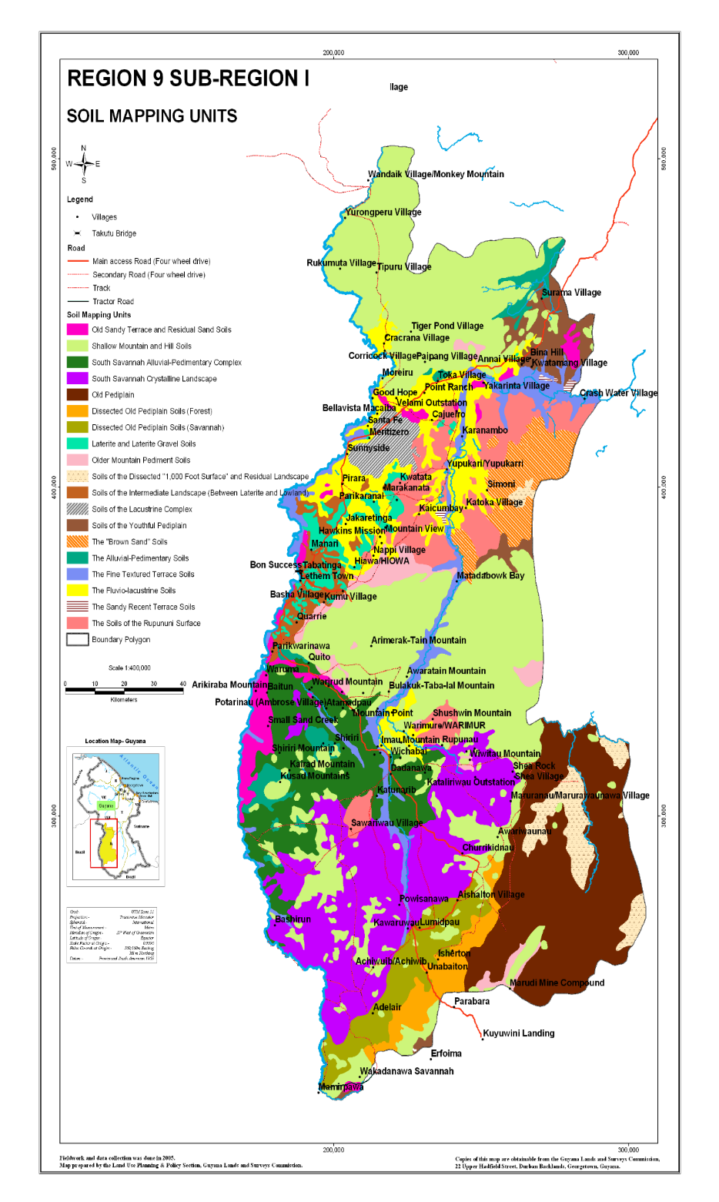

ANNEX 4. Requirements of the Ebini station

Crop Production
Improved varieties of selected crop species

Livestock
Pure bred beef breeds
Bahaman Zebu
Beefmaster
Brangus
Work Horses

Machinery
Tractors: Two four wheel drive tractors
Implements: Rome harrow, disc plough, 2 brush cutter, one 3 gang and one single gang.
Planter: One- two row planter
Grain harvester: 1 Combine harvester for grain crops
Trailers: Two cattle trailers
4-Wheel Drive vehicles
Tool kits, two complete tool sets, one metric one standard
Arc welding set
Acetylene welding set

Irrigation system
Water reservoir
Solar water pump with Voltaic cells:
800 – Gallon water tanks:
Pines and connections:
Drip lines:

Infrastructure for animal production:
Spray race for cattle: One
Fencing material – posts, wire etc.
Cattle chute
Feed processor and mixer
Feed shed
Feed troughs
Biogas digester

Processing equipment
Processing Unit with packaging and cold storage facilities
Juicer/ Seed extractor
Fruit/vegetable driers

Infrastructure for Extension Services
Boat and engine:
Life Vests

Other support Infra-structure:
Houses: Repair of 16 houses
Office/Training Centre: Furnishings for Office, equipment for training Centre (to be detailed)
Dormitory: For trainees (refurbish old school building)
Dormitory equipment: Stoves, beds, mattress, sheets, etc
Electricity: Standby generator, solar equipment for houses and office
Telephone: Improved system
Domestic water supply: Rehabilitation of domestic water system and storage tank
Internet connection:
Grader for road upkeep: One
Mowers: Three riding for upkeep of fields, lawns and airstrip
Chain saws: Two

ANNEX 5. List of Chemicals and Equipment needed for the re-activation of the NAREI Laboratory at Mon Repos
- List of Chemical Required by the Soil Chemistry Laboratory
Chemical | Catalogue | Quantity | Unit Price | Total Price
Hydrogen Peroxide (30%) (H2O2) | Rocky’s Pharmaceutical | 4 litre | 8,987.20/500ml | 71896
Antifoam B |  | 1kg | 16,500/500g | 33,000
Saturated Sodium Chloride | Rocky’s Pharmaceutical | 2.5Kg |  | 16,450.00
Sodium Dithionite (Na2S2O4) |  | 2 Kg | 29,784.00/kg | 59,568
5% Sodium Hexametaphosphate (Calgon) |  | 2Kg | 21,650/kg | 43,300
Acetone | Rocky’s Pharmaceutical | 5 litre |  | 32,274
Citric Acid | Fisher Scientist 2008/09 | 4 kg |  | 92,176
Phenol | Fisher Scientist 2008/09 | 500g |  | 17,920
Sodium Bicarbonate (NaHCO3) | Rocky’s Pharmaceutical | 2Kg | 9,971/kg | 19,942
Na-Citrate Dihydrate |  | 2Kg | 14,169/kg | 28,338
L-Ascorbic Acid | Fisher Scientist 2008/09 | 4Kg | 33400/2kg | 133,600
Ammonium Fluoride (NH4F) | Fisher Scientist 2008/09 | 4Kg | 42,508/kg | 170,032
Ammonium Molybdate (NH4)6 | Rocky’s Pharmaceutical | 4Kg | 139,072/kg | 556,288
Boric Acid (H3BO3) | Fisher Scientist 2008/09 | 4Kg | 15,350 | 61,400
Potassium Antimony Tartarate (KSbO C4 H4 O6) |  | 500g | 31,540 | 31,540
Ammonium Acetate (NH4O Ac) | Fisher Scientist 2008/09 | 10Kg | 28,470.40/kg | 284,704
Hydrochloric Acid 37% (HCl) | Fisher Scientist 2008/09 | 2.5 litre | 3,500.02/litre | 8,750
Concentrated Sulphuric Acid | Rocky’s Pharmaceutical | 10 litre | 4,950/litre | 49,500
Standards for AA Spectrometer: 1000 ppm  Calcium (Ca) | Fisher Scientist 2008/09 | 2 litre | 11,100 | 22,200
1000 ppm Sodium (Na) | Fisher Scientist 2008/09 | 2 litre | 8,500/L | 17,000
1000 ppm Magnesium (Mg) | Rocky’s Pharmaceutical | 2 litre | 34,840/L | 69,680
1000 ppm Manganese (Mn) | Rocky’s Pharmaceutical | 2 litre | 282,280/L | 564,560
1000 ppm Iron (Fe) | Rocky’s Pharmaceutical | 2 litre | 282,280/L | 564,560
1000 ppm Zinc (Zn) | Rocky’s Pharmaceutical | 2 litre | 282,280/L | 564,560
1000 ppm Potassium (K) | Rocky’s Pharmaceutical | 2 litre | 29,552/L | 59,104
1000 ppm Copper (Cu) | Rocky’s Pharmaceutical | 2 litre | 282,280/L | 564,560
Potassiun Chloride | Cole Parmer | 5Kg | 35,400/kg | 177,000
Potassium Dichromate | Western Scientific | 4Kg | 13,200/kg | 52,800
Ferrous Sulphate | Western Scientific | 4Kg | 12,400/kg | 49,600
Potassium Sulphate Powder, Reagent, ACS | Cole Parmer | 500g | 14,900/100g | 74,500
Selenium Tablets | Cole Parmer | 500 |  | 21,400
Bromocresol Green Indicator | Cole Parmer | 500 ml |  | 4,300
Methyl Red Indicator | Cole Parmer | 500 ml |  | 9,200
Parafilm “M” Laboratory film | Cole Parmer | 10 rolls | 5,690/roll | 56,900
Heavy duty gloves (handling of concentrated sulphuric acid). | Cole Parmer | 10 Pairs | 2250/pair | 22,500
Dust respirators | Cole-Parmer 2007/08. | 10 Boxes | 1880/box | 18,800
Total cost of Chemicals required |  |  |  | G$4,623,902.00
 |  |  |  | US$23,120.00

- List of Equipment for Soil Chemistry Laboratory
Equipment | Specifications | Catalog | Equipment # | Quantity | Price ($US) | Total  ($GY)
Visible Spectrophotometer | - Bandwidth: 8 nm  - Wavelength range: 320 to 1000 nm  - Wavelength accuracy: + or – 2 nm  - Source lamp: Tungsten halogen  - Display: 4-digit LCD  - Power (50/60 Hz): 115 Vac | Cole-Parmer  2007/08. | KH-83054-00 | 1 | $2100.00 | 420,000
Barnstead Automatic Glass Stills  Storage Reservoir Bottle | Output - 2 litre/hour  8 litre polyethylene bottle with faucet and wall bracket. 8’’W x 17’’ x 61/2’’D | Cole/Parmer 2007/08  Cole/Parmer 2007/08 | KH-99292-35  KH-01535-25 | 1  1 | $3290.00  $442.00 | 658,000  88,400
1. Chempette Digital Repetitive Dispensers  2. Chempette Digital Repetitive Dispensers | Volume: 1 to 5mL  Increments: 0.02mL  Volume: 2 to 10mL  Increments: 0.10mL | Cole-Parmer  2007/08.  Cole-Parmer  2007/08. | KH-07848-30  KH-07848-40 | 1  1 | $288.00  $288.00 | 57,600  57,600
Glass-Tip Pipettors | Dispensing range: 1 to 10mL | Cole-Parmer  2007/08. | KH-07908-39 | 1 | $494.00 | 98,800
Replacement Glass Tip | Dispensing range: 1 to 10mL | Cole-Parmer  2007/08. | KH-07908-47 | 1 | $87.00 | 17,400
Analytical Balance with Internal Calibration | Capacity: 260g  Readability: 0.0001g | Cole-Parmer  2007/08. | KH-11018-44 | 1 | $3270.00 | 654,000
Benchtop pH Meter  pH Buffer Solution | Double-junction pH electrode, ATC probe and removable swing-arm electrode holder.  pH – 4.01 : 4-L bottle | Cole-Parmer  2007/08.  Cole-Parmer  2007/08. | KH-35619-10  KH-05942-24 | 2  1 | $1244.00  $35.00 | 497,600  7,000
pH Buffer Solution | pH – 7.00: 4-L bottle | Cole-Parmer  2007/08. | KH-05942-44 | 1 | $35.00 | 7,000
Salt Tester | Oakton Eco Tester – Salinity tester | Cole-Parmer | 16,300/each | 2 | $81.50 | 32,600
Accessories for equipment |  |  |  |  |  | 254,600
Top loading balance | 4000g capacity | Cole-Parmer, 2007/08 | KH-10000-30 | 1 | $371.00 | 74,200
Total cost of Equipment required |  |  |  |  |  | G$2,924,800.00
 |  |  |  |  |  | US$14,624.00

Accessories
US$ G$
1. KH- 06343-10 Replacement cuvettes. Pack of 500 $94.00/pk 18,800
2. KH-83056-20 Replacement tungsten halogen lamp $63.50 12,700
3. KH-83054-53 Cuvette holder, 20 to 100 mm $241.00 48,200
4. KH-83054-70 Dust cover $42.50 8,500
5. KH-53020-52 RS-232 cable $138.00 27,600
6. KH-21081-30 Collect Software for Windows $582.00 116,400
7. KH-06720-34 Parafilm dispenser clear acrylic $112.00 22,400

ANNEX 6. Crop production packages in the Intermediate Savannahs for selected commodities
Table 1: Cost of production studies for black eye peas in the Intermediate Savannahs (NAREI, 2014)
Parameters | Unit costs | Actual Costs
Land preparation 1 plough and 2 harrow | $29,650/ha | $23,518.00
Planting costs (2 hours) | $4,000.00 | $2000.00
Seed cost | $1000/kg | $11,400.00
Fertilizing application (hand) 1 person ½ day | $1,000.00 | $1,000.00
Cost of fertilizer per bag
12-12-17-2 | $7,000.00 | $11,822.00
Pesticides
Pesticide application (hand) 1 person ½ day | $1,000.00 | $1,000.00
Round-up, 2 L/ha (one application) | $1,650/L | $1,254.00
Select- 12 @ 2L/ha $9,750/L (2 applications) | $9,750.00 | $14,820.00
Harvesting hand (pod weight) | $44-55/kg | $30,628.00
Processing (pod weight) | $30/kg | $18,377.00
Cost of empty bags (1 bag to 50kg) | $40/bag | $360.00
Total cost |  | $111,179.00
Cost /ha |  | $292,576.00
Cost/kg |  | $244.00
Transportation from Berbice river to New Amsterdam | $200/bag
Wholesale price in GT $960/gal (1 gl. of peas = 3.6 kg (8 lbs) | $266.00/kg

Table 2: Cost of Production for Minica 4 Studies (NAREI, 2014)
Parameters | Unit costs |  | Actual Costs
 |  | Plot (1.2 ha) | Plot 2 (.32 ha)
Land preparation 1 plough and 2 harrow | $29,650/ha | $35,580.00 | $9,488.00
Planting costs (2 hours) | $4,000.00 | $4,000.00 | $2,000.00
Seed cost | $1000/kg | $30,000.00 | $8,000.00
Fertilizing application (hand) 1 person ½ day | $1,000.00 | $1,000.00 | $1,000.00
Cost of fertilizer per bag
12-12-17-2 | $7,000.00 | $17,888.00 | $10,111.00
Pesticides
Pesticide application (hand) 1 person ½ day (3) | $1,000.00 | $3,000.00 | $3,000.00
Round-up, 2 L/ha (one application) | $1,650/L | $3,960.00 | $1,056.00
Select- 12 @ 2L/ha (2 applications) | $9,750/L | $46,800.00 | $12,480.00
Harvesting hand (pod weight) | $44-55/kg | $158,040.00 | $34,080.00
Processing (pod weight) | $30/kg | $94,824.00 | $20,428.00
Cost of empty bags (1 bag to 50kg) | $40/bag | $1,850.00 | $407.00
Total cost |  | $396,942.00 | $102,050.00
Cost /ha |  | $330,785.00 | $318,906.00
Cost /kg of red pea |  | $172.00 | $201.00
Wholesale price/kg, delivered in Georgetown (10/10/2014) |  | $528.00
Wholesale price at Berbice river ( 10-10-2014) |  | $660.00
Transportation from Berbice river to New Amsterdam |  | $200/bag

Table 3: Estimated cost of production for Peanuts in the Intermediate Savannahs
Parameters | Unit costs | Actual Costs
Land preparation 1 plough and 2 harrow | $29,650/ha | $29,650.00
Planting costs (2 Man days) | $2,000.00 | $4,000.00
Seed cost | $1000/kg | $35,000.00
Fertilizing application (3 applications =3 Man day) | $2,000.00 | $6,000.00
Cost of fertilizer
12-12-17-2 250kg/ha | $7,000.00 | $17,500.00
DAP 100kg/ha | $90/kg | $9,000.00
TSP 50kg/ha | $72/kg | $3,600.00
Sul-po-mag 250 kg/ha | $80/kg | $20,000.00
F.T.E. Trace 40kg/ha | $300/kg | $12,000.00
Gypsum 500kg/ha | $40/kg | $20,000.00
Pesticides
Pesticide application (hand) 1 person ½ day per application | $1,000.00 | $3,000.00
Round-up, 2 L/ha (one application) | $1,650/L | $1,254.00
Kocide @ 0.8L/ha $8,800/L (2 applications) | $8,800.00 | $13,200.00
Harvesting hand (8 Man days) | $2,000.00 | $16,000.00
Shelling (8 Man days) | $2,000.00 | $16,000.00
Cost of empty bags (1 bag to 25kg) | $40/bag | $8,000.00
Total cost |  | $214,204.00
Cost /ha |  | $214,206.00
Cost/kg Yield 5,000kg/ha |  | $42.84

Table 4: Estimated Cost of production for Cassava in the Intermediate Savannahs
Parameters | Unit costs | Actual Costs
Land preparation 1 plough and 2 harrow | $29,650/ha | $29,650.00
Planting costs (6 Man days) | $2,000.00 | $12,000.00
Seed cost (10,000 Planting sticks) | $2/stick | $20,000.00
Fertilizing application (1 Man day) | $2,000.00 | $2,000.00
Cost of fertilizer per bag
12-12-17-2 | $7,000.00 | $14,000.00
Pesticides
Pesticide application (hand) 1 person ½ day | $1,000.00 | $1,000.00
Round-up, 2 L/ha (one application) | $1,650/L | $3,300.00
Gramoxone 2 L/ha (2 applications spot spray) | $975.00 | $1,950.00
Harvesting hand (root weight) | $20/kg | $200,000.00
Cost of empty bags (1 bag to 40kg) | $40/bag | $16,000.00
Total cost |  | $299,900.00
Cost /ha |  | $299,900.00
Cost/kg Yield 10,000kg/ha |  | $30.00

Table 5. Establishment cost for Orchard Crops at Ebini (Cumberbatch et al., 2015)
Parameters | Establishment Cost
 | Unit | $/Unit | $/Plant | $/Plant/yr | Total cost
Land Preparation | ha | $30,000.00 | $521.00
Digging Pits manually
Planting
Liming
Cost of plant  1. Avocado - $200.00  2. Avocado (G) - $260.00  3. R. Lemon - 200.00  4. Guava - $100.00  5. Soursop - $100.00  6. G. Apple - $500.00 | 1. 24 x $200  2. 9 x $260  3. 48 x 200  4. 24 x $100  5. 31 x $100  6. 8 x $500 | $26,240.00 | $182.00 | $182.00 | $26,240.00
Manure | 5kg/plant | $500.00/20kg | $125.00 | $125.00 | $18,000.00
Establishment Total |  |  | $ |  | $144,392.00
Operating cost
Manure | 5kg/plant | $500.00/20kg | $125.00 | $250.00 | $36,000.00
Weeding | Entire Orchard 2times per month | $30,000.00/mth | $208.00 | $2,500.00 | $360,000.00
Pest control | Twice/Mnth | $3000.00/L | $7.00 | $83.00 | $12,000.00
Circle weeding | Each Plant | 2 man days @ $2000/day | $333.00 | $4,000.00 | $48,000.00
Fertilizer 12:12: 17:2 | 250g/plant | $7500/45kg | $42.00 | $84.00 | $12,000.00
Lime application | 250g/plant | 1500/45Kg | $8.00 | $16.00 | $2,304.00
Irrigation | 3800 L/mnth | $30,000.00 | $208.00 | $625.00 | $90,000.00
Pruning etc | 2 times/yr | $10,000.00 | $69.00 | $139.00 | $20,000.00
Watering | 36 times/yr | 1 Man day @ $2000/day | $14.00 | $500.00 | $72,000.00
Operating cost |  |  |  |  | $652,304.00
Total cost |  |  |  |  | $796,696.00

